ARJITA SAXENA (155405)

MINIPROJECT: CENSUS REPORTING SYSTEM

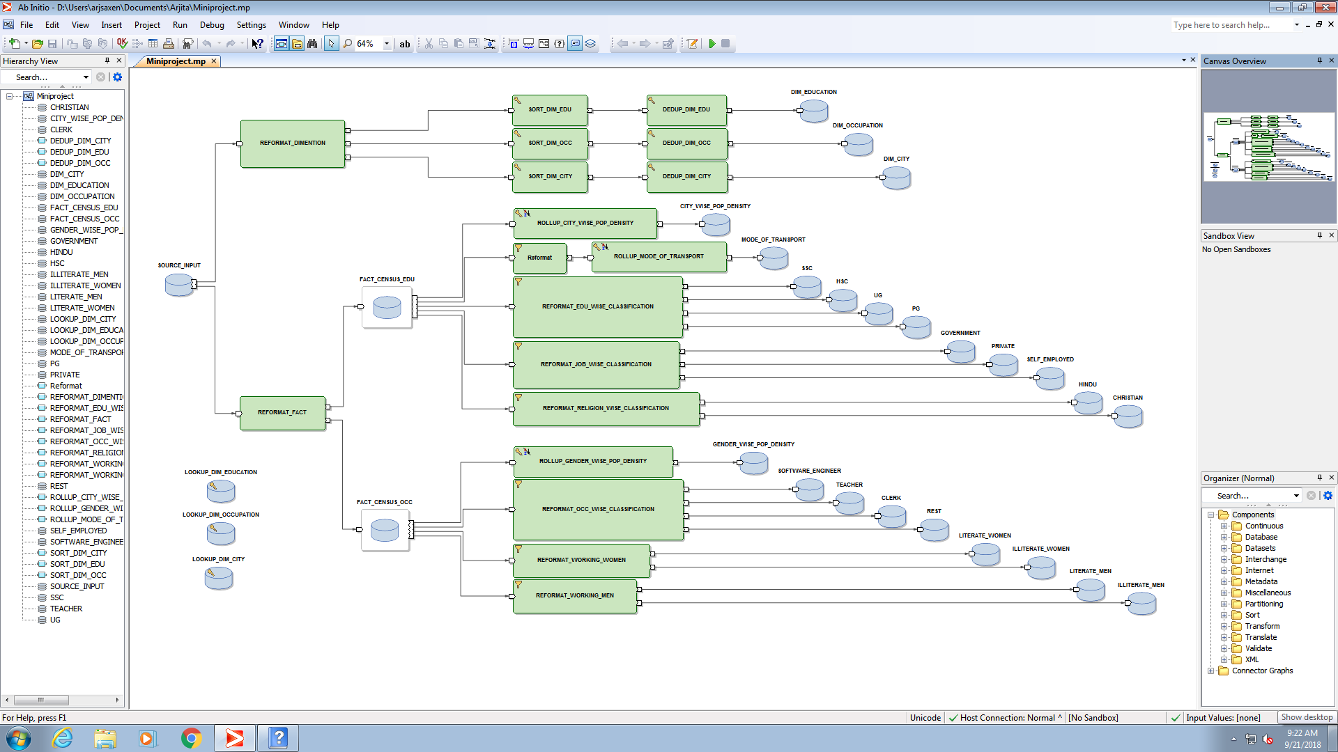

SOURCE INPUT DATA

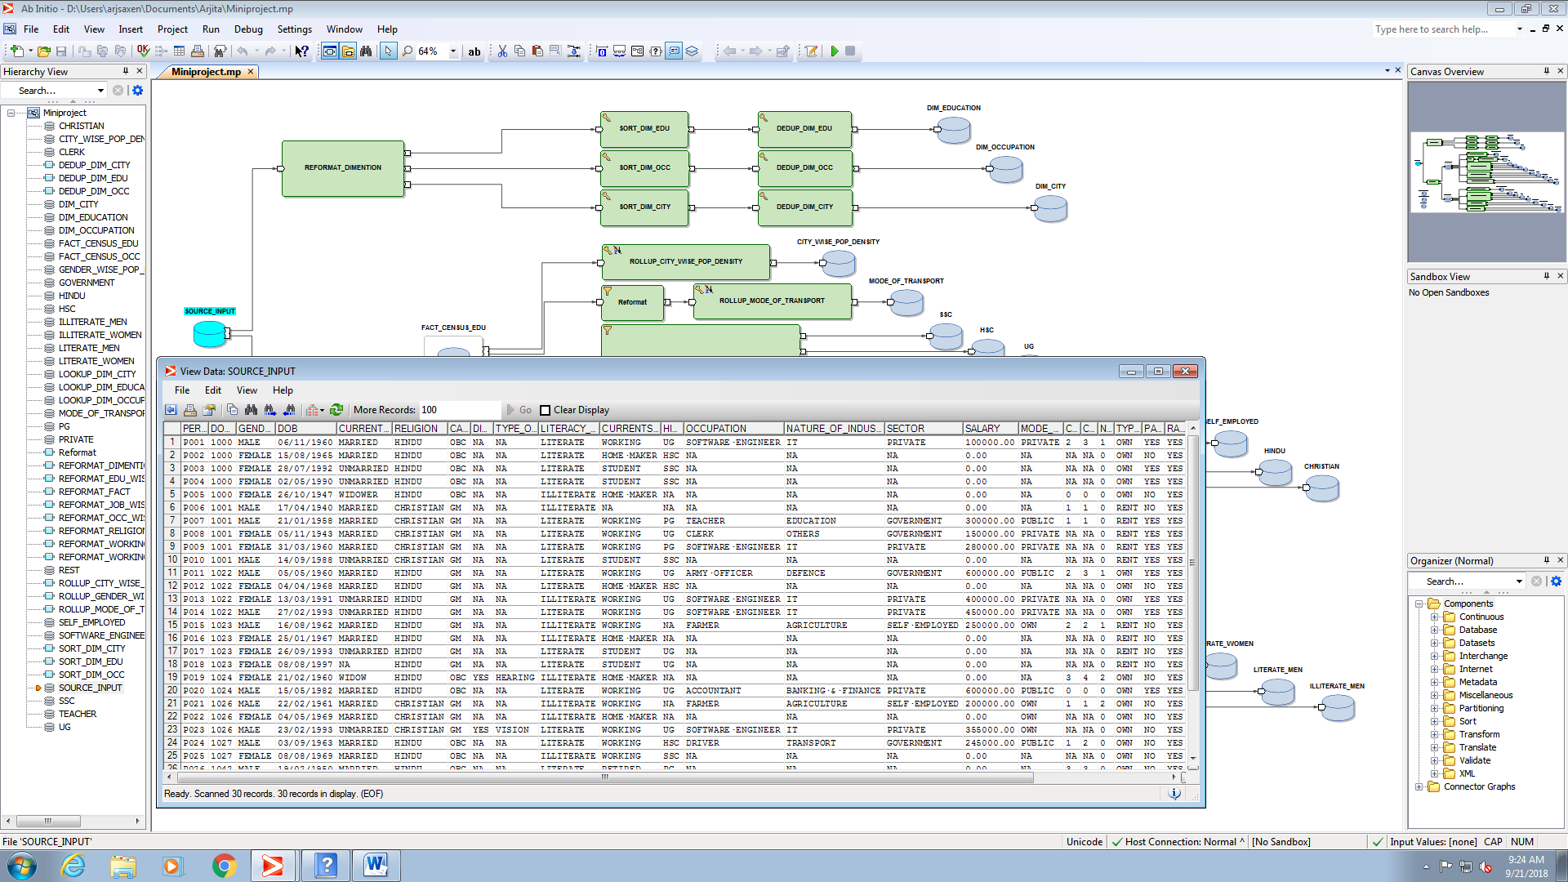

LOOKUP FOR EDUCATION DIMENTION TABLE

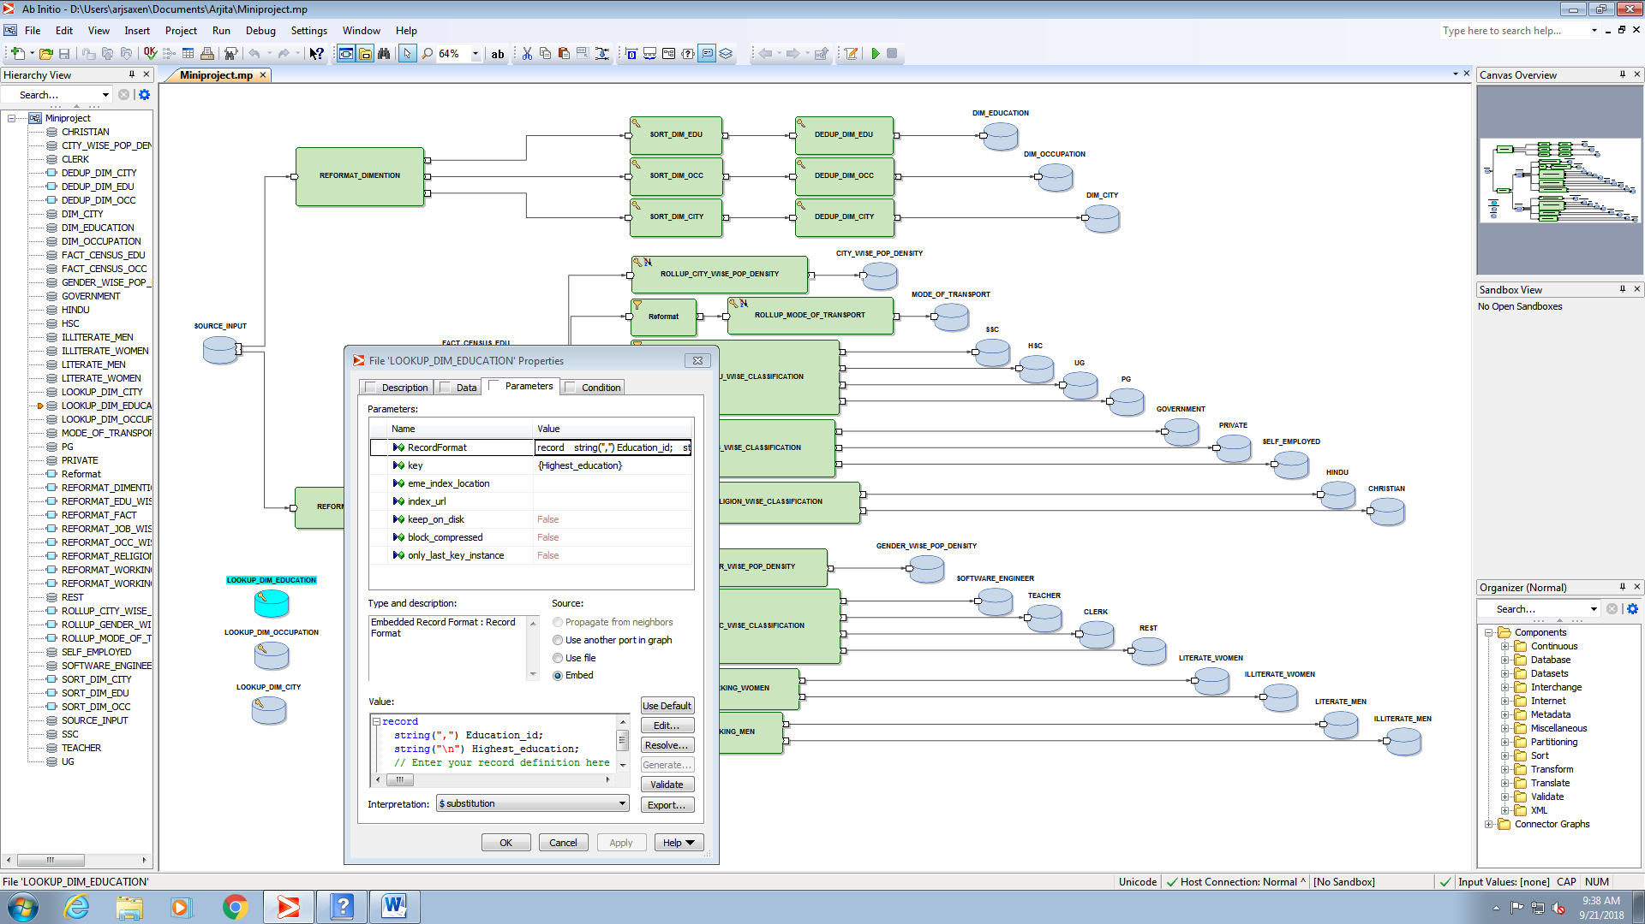

LOOKUP FOR OCCUPATION DIMENTION TABLE

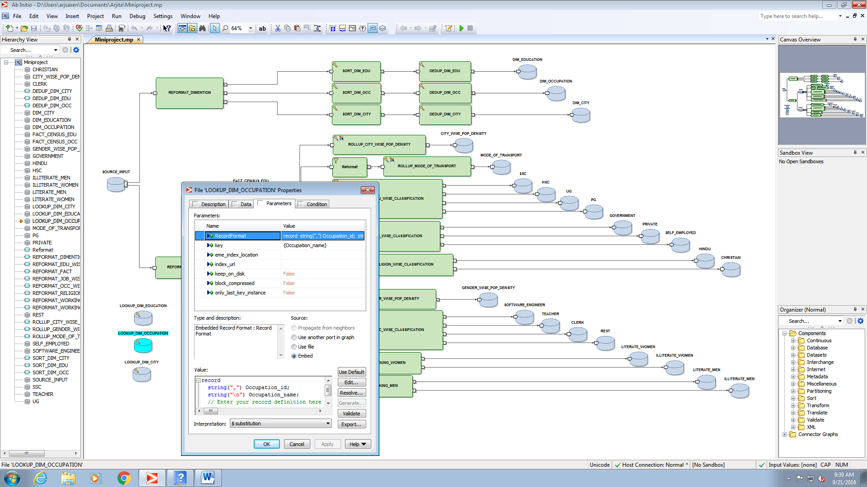

LOOKUP FOR CITY DIMENTION TABLE

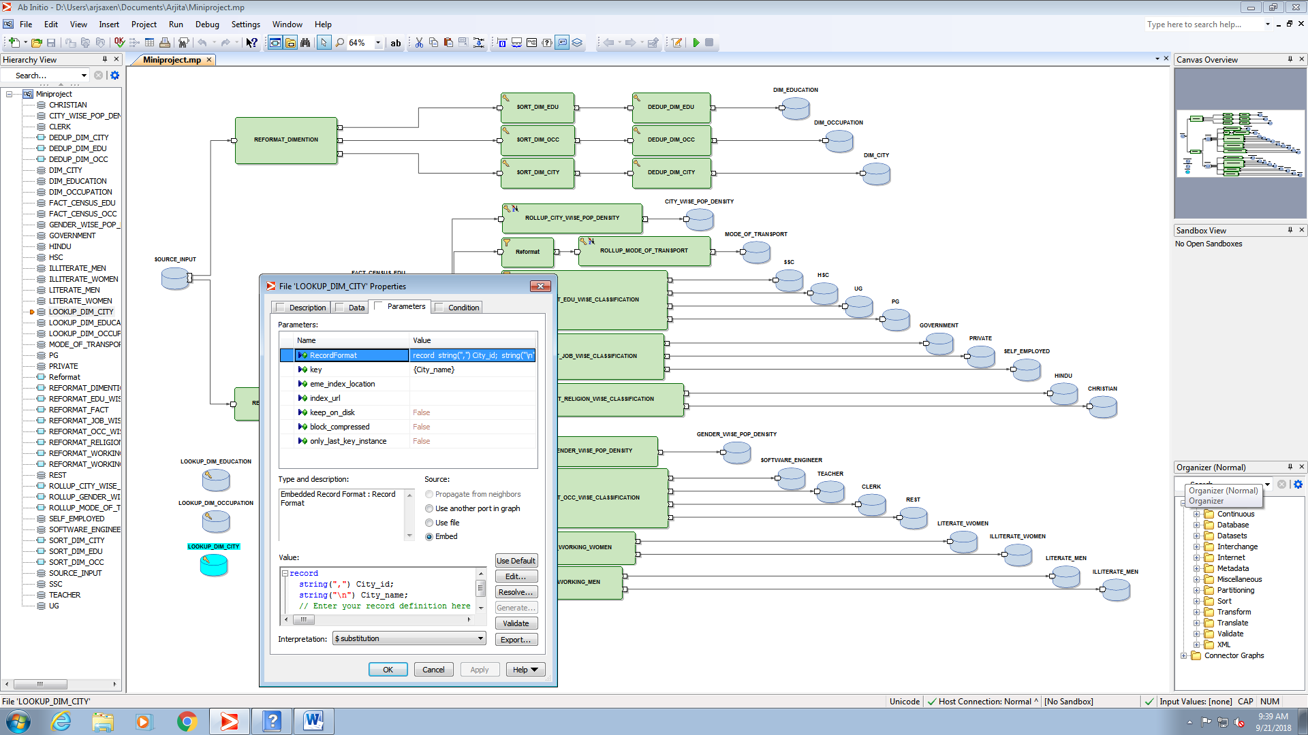

REFORMAT FOR DIMENTION TABLES

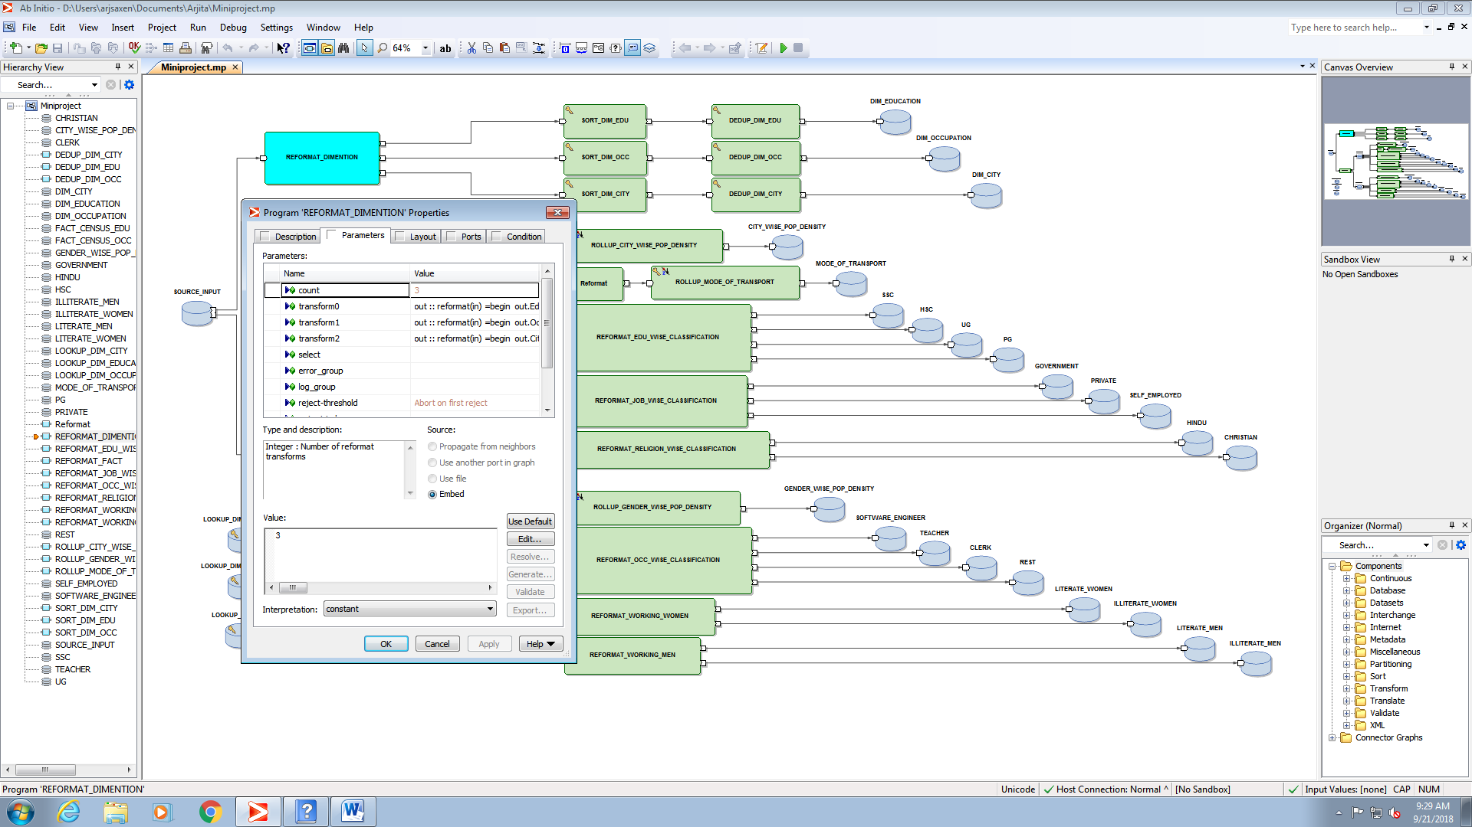

SORTING DATA IN DIMENTION TABLES USING SORT COMPONENT

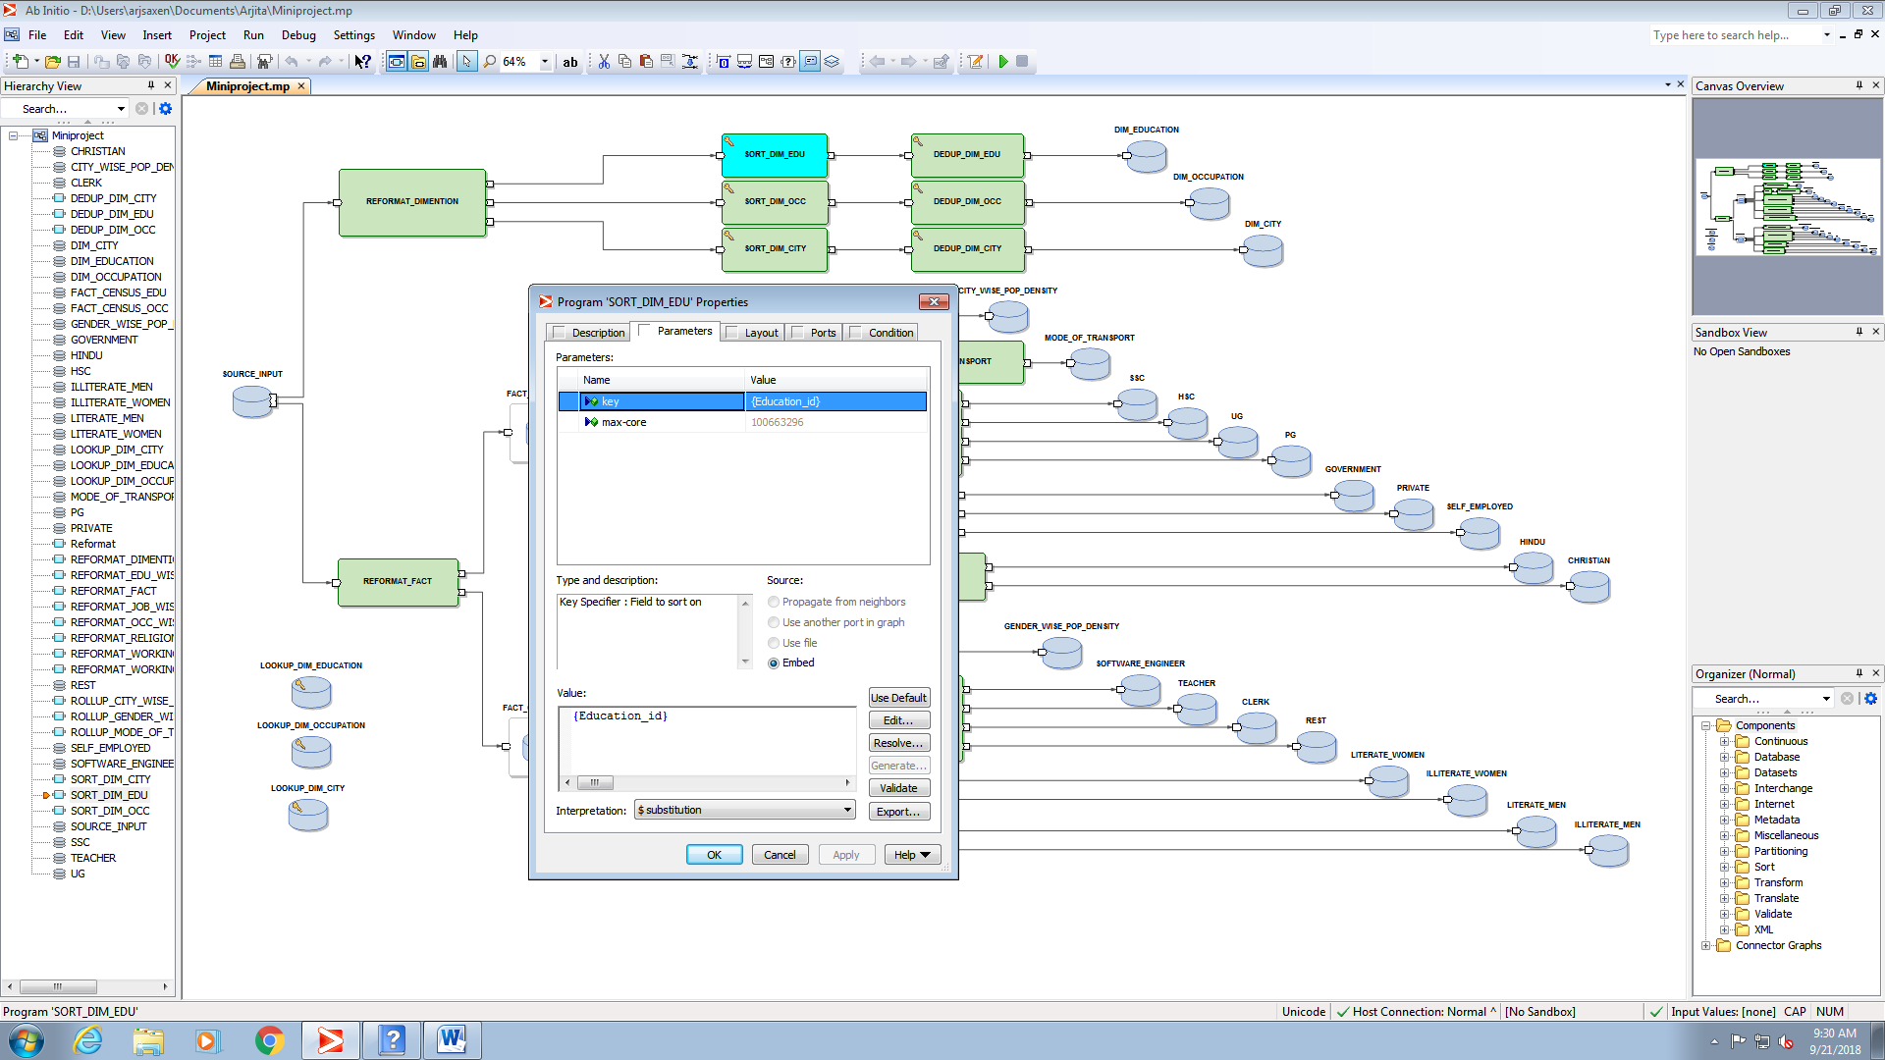

DELETING DUPLICATE DATA IN DIMENTION TABLES USING DEDUP COMPONENT

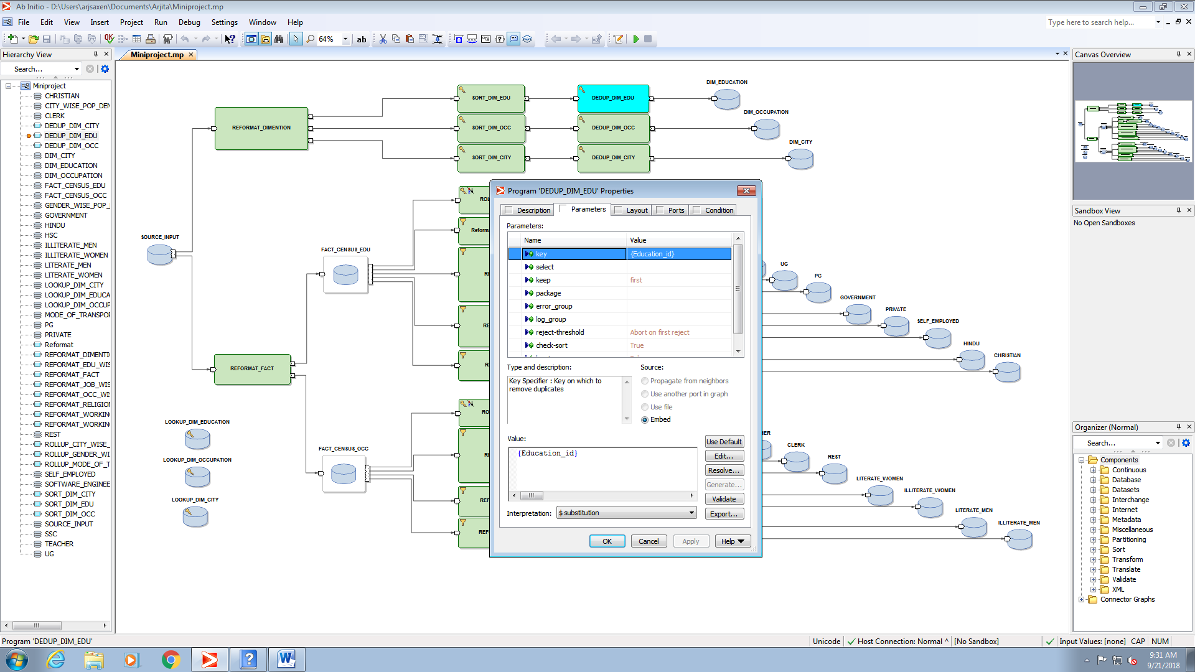

OUTPUT OF EDUCATION DIMENTION TABLE

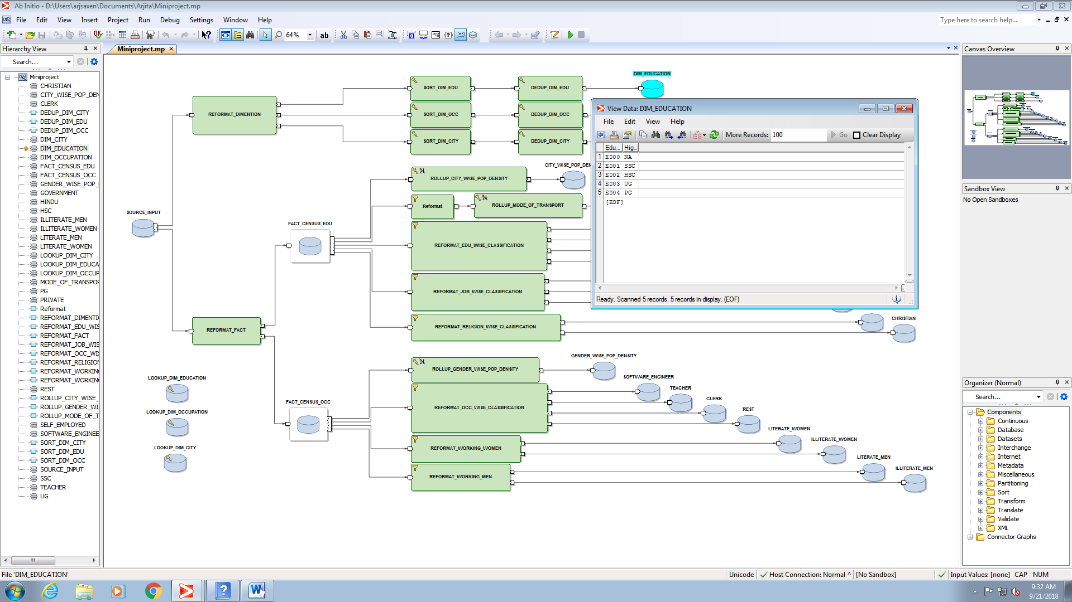

OUTPUT OF OCCUPATION DIMENTION TABLE

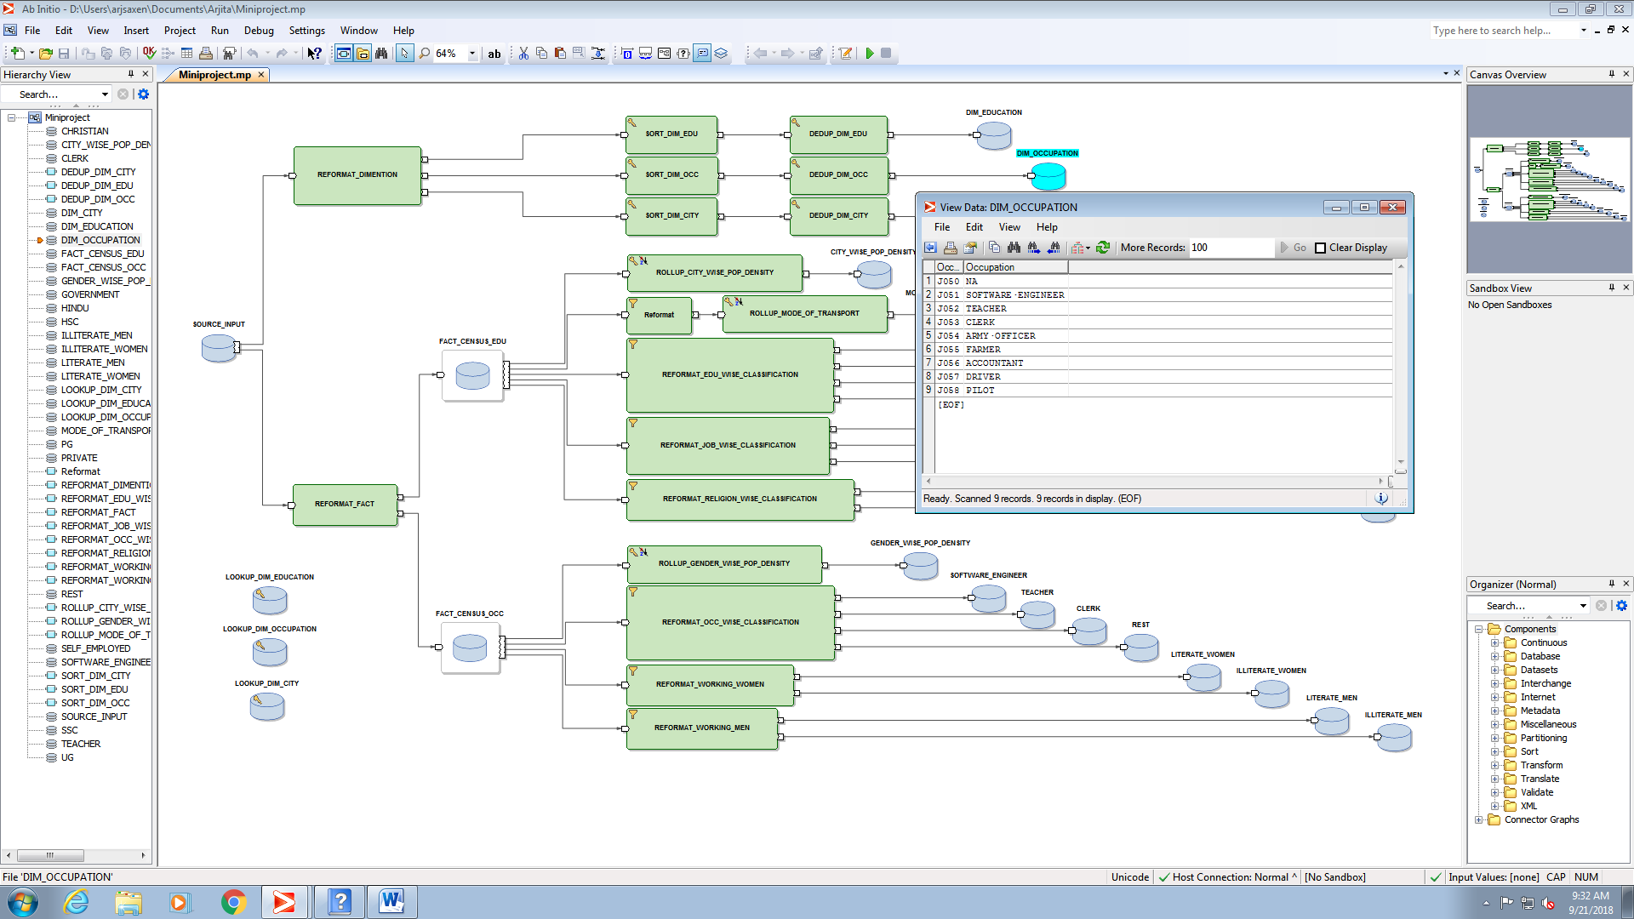

OUTPUT OF CITY DIMENTION TABLE

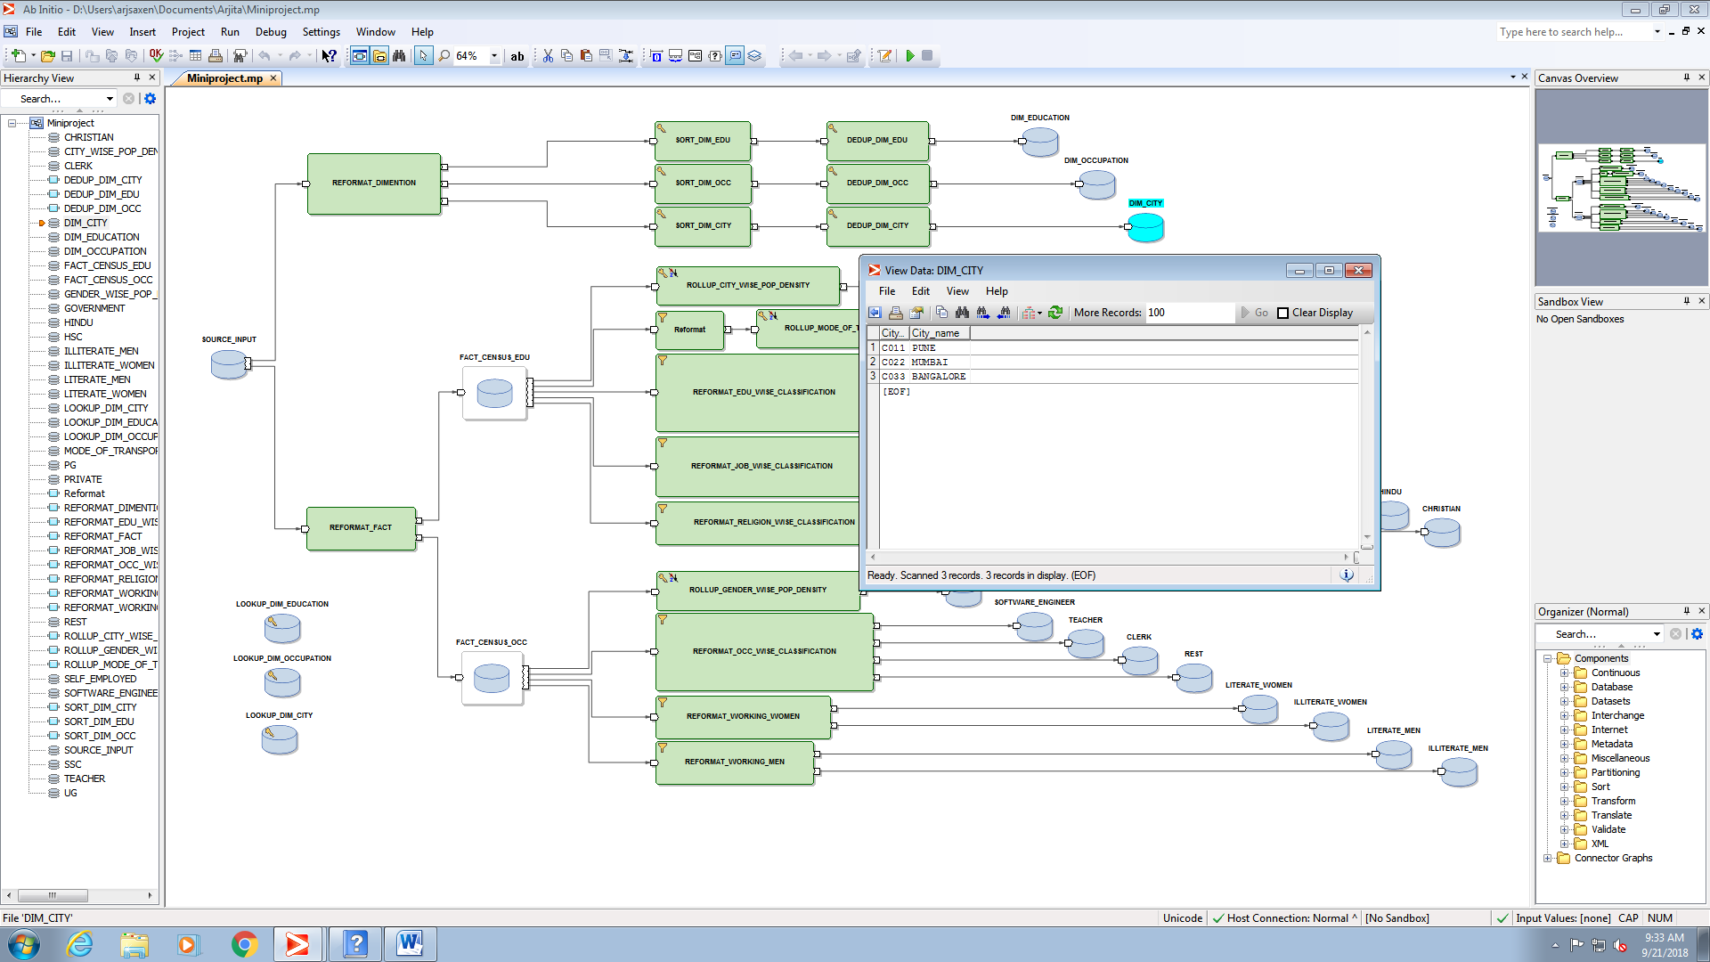

REFORMAT FOR DIMENTION TABLES

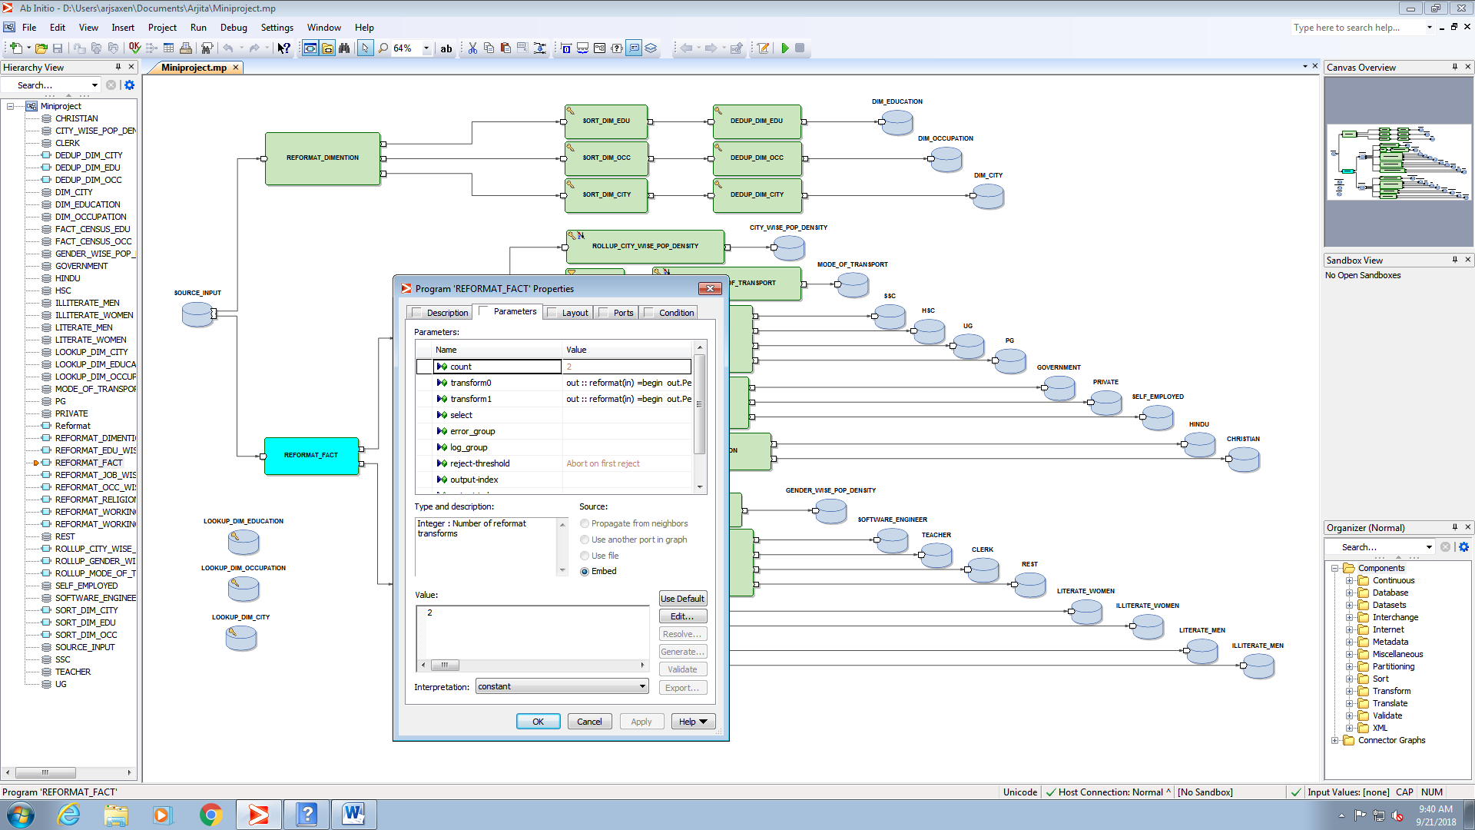

INTERMEDIATE FILE FOR EDUCATION FACT TABLE

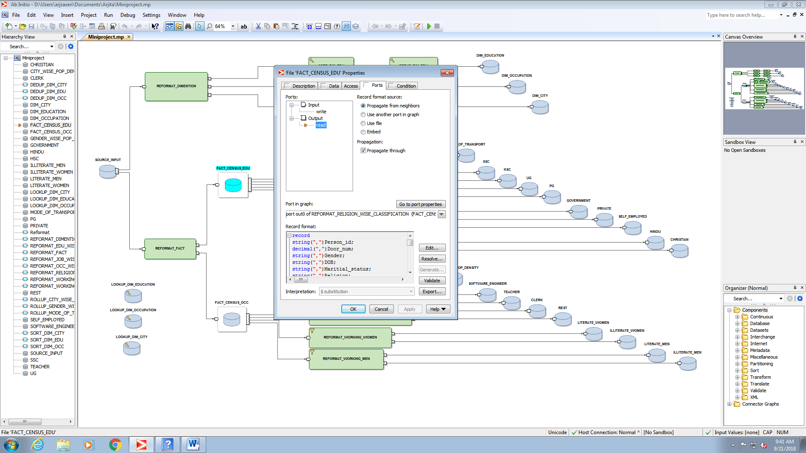

INTERMEDIATE FILE FOR OCCUPATION FACT TABLE

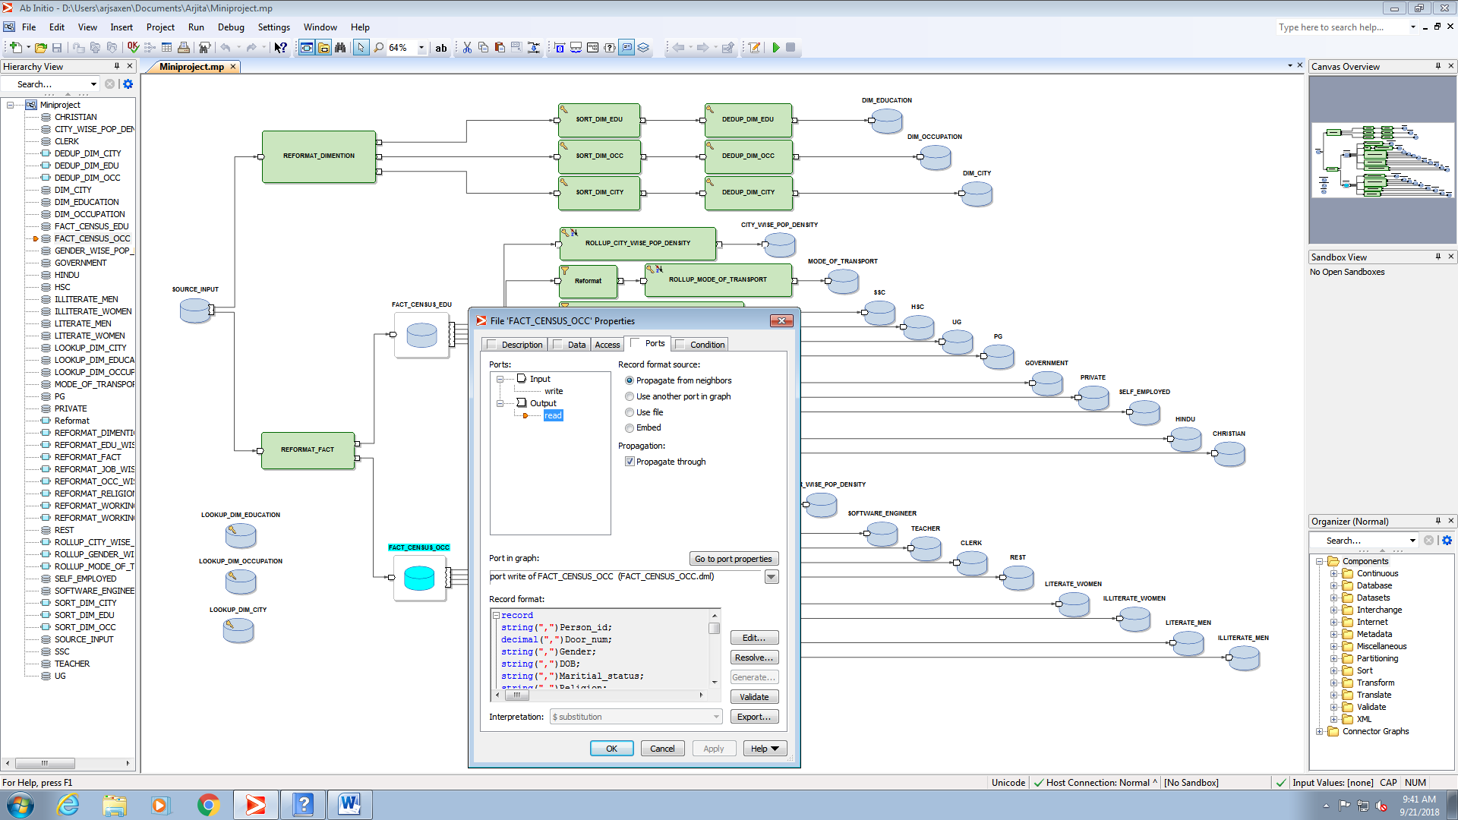

REPORTS:-

1. CITY WISE POPULATION DENSITY

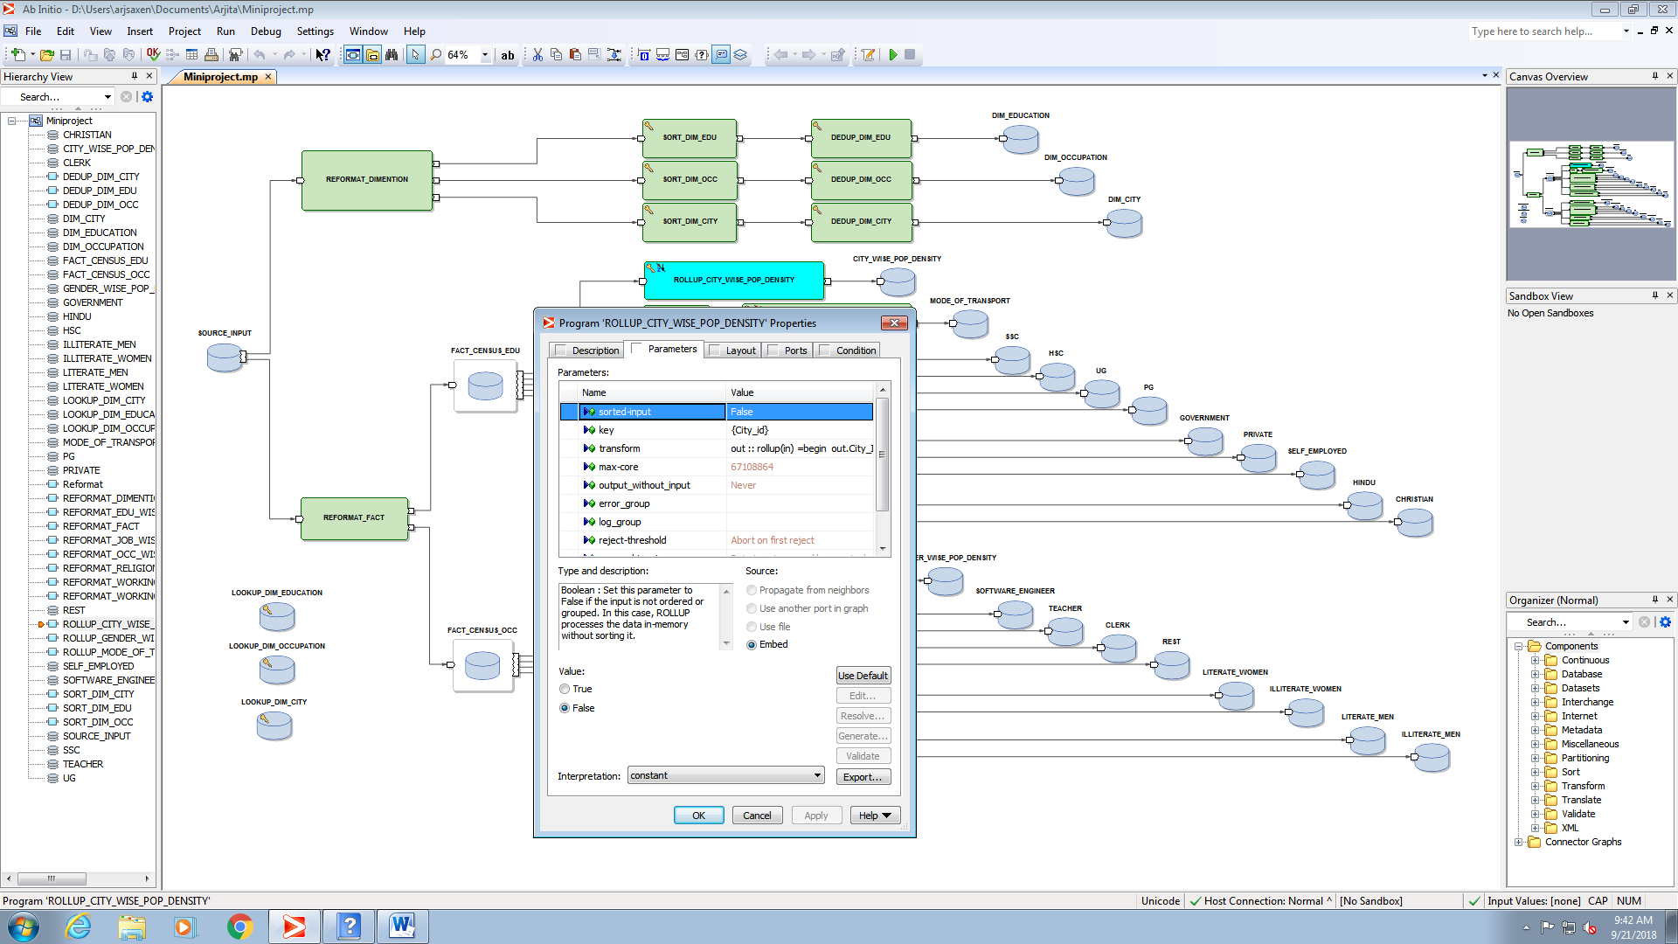

OUTPUT:

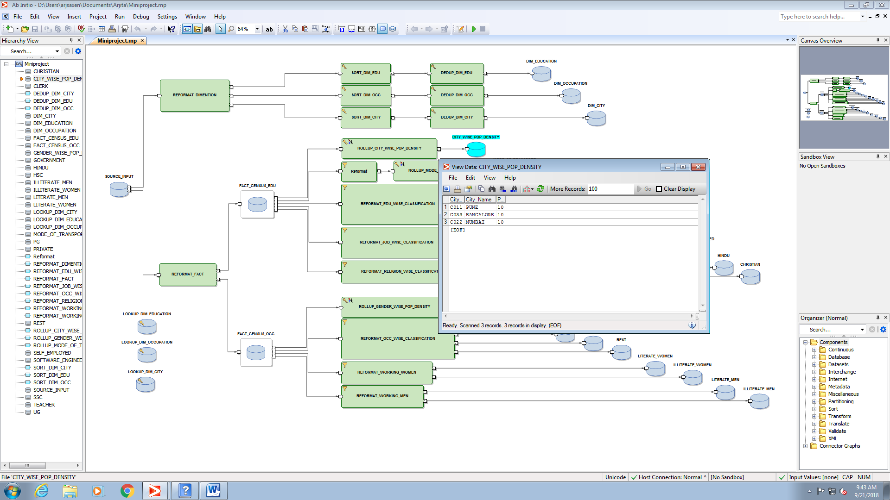

1. MODE OF TRANSPORT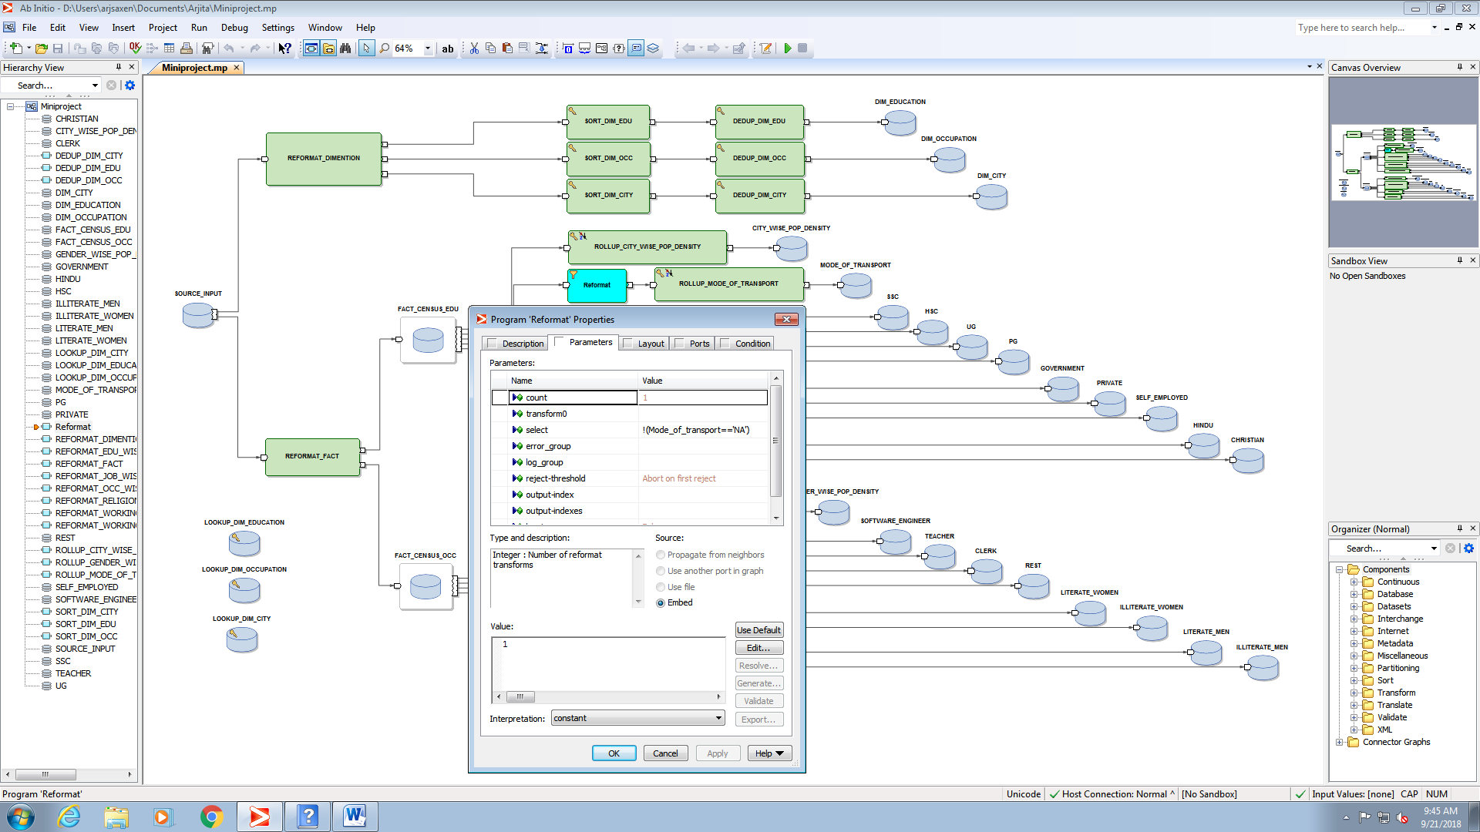

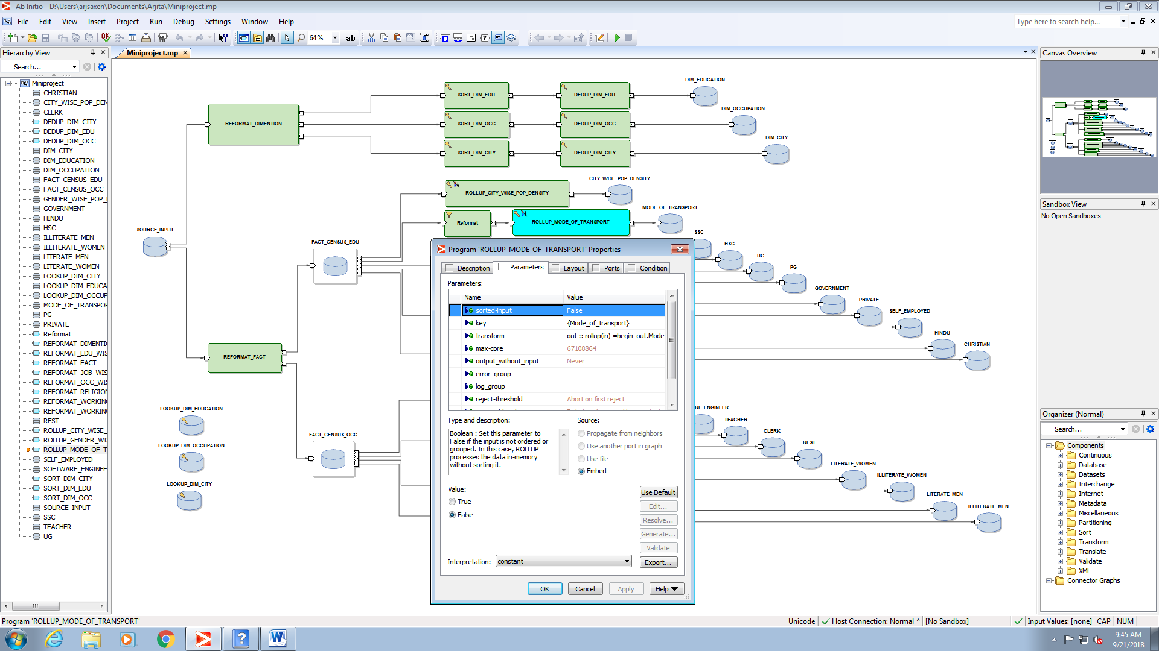

OUTPUT:

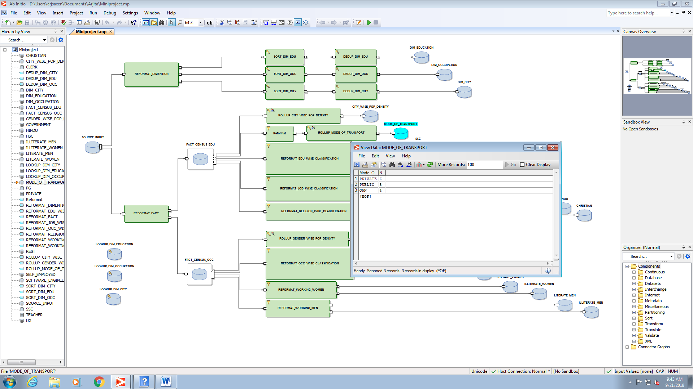

1. EDUCATION WISE CLASSIFICATION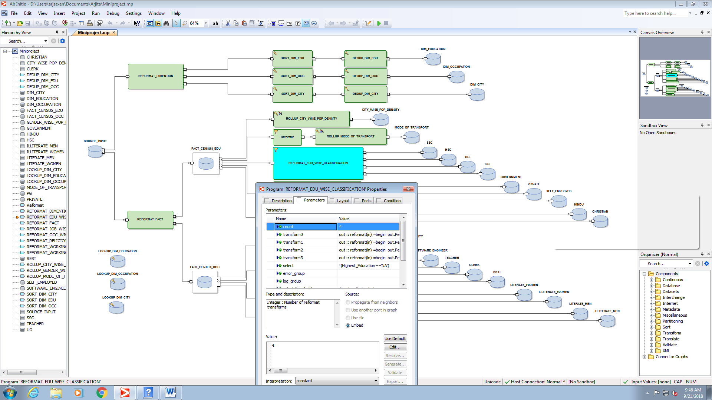
2. SSC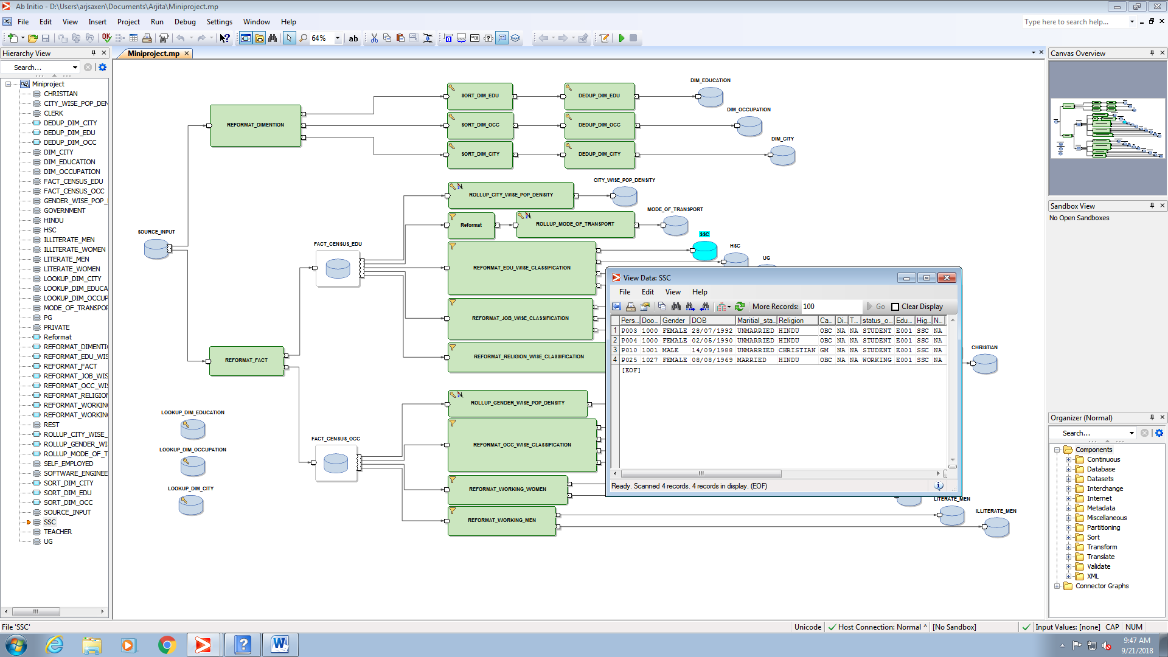
3. HSC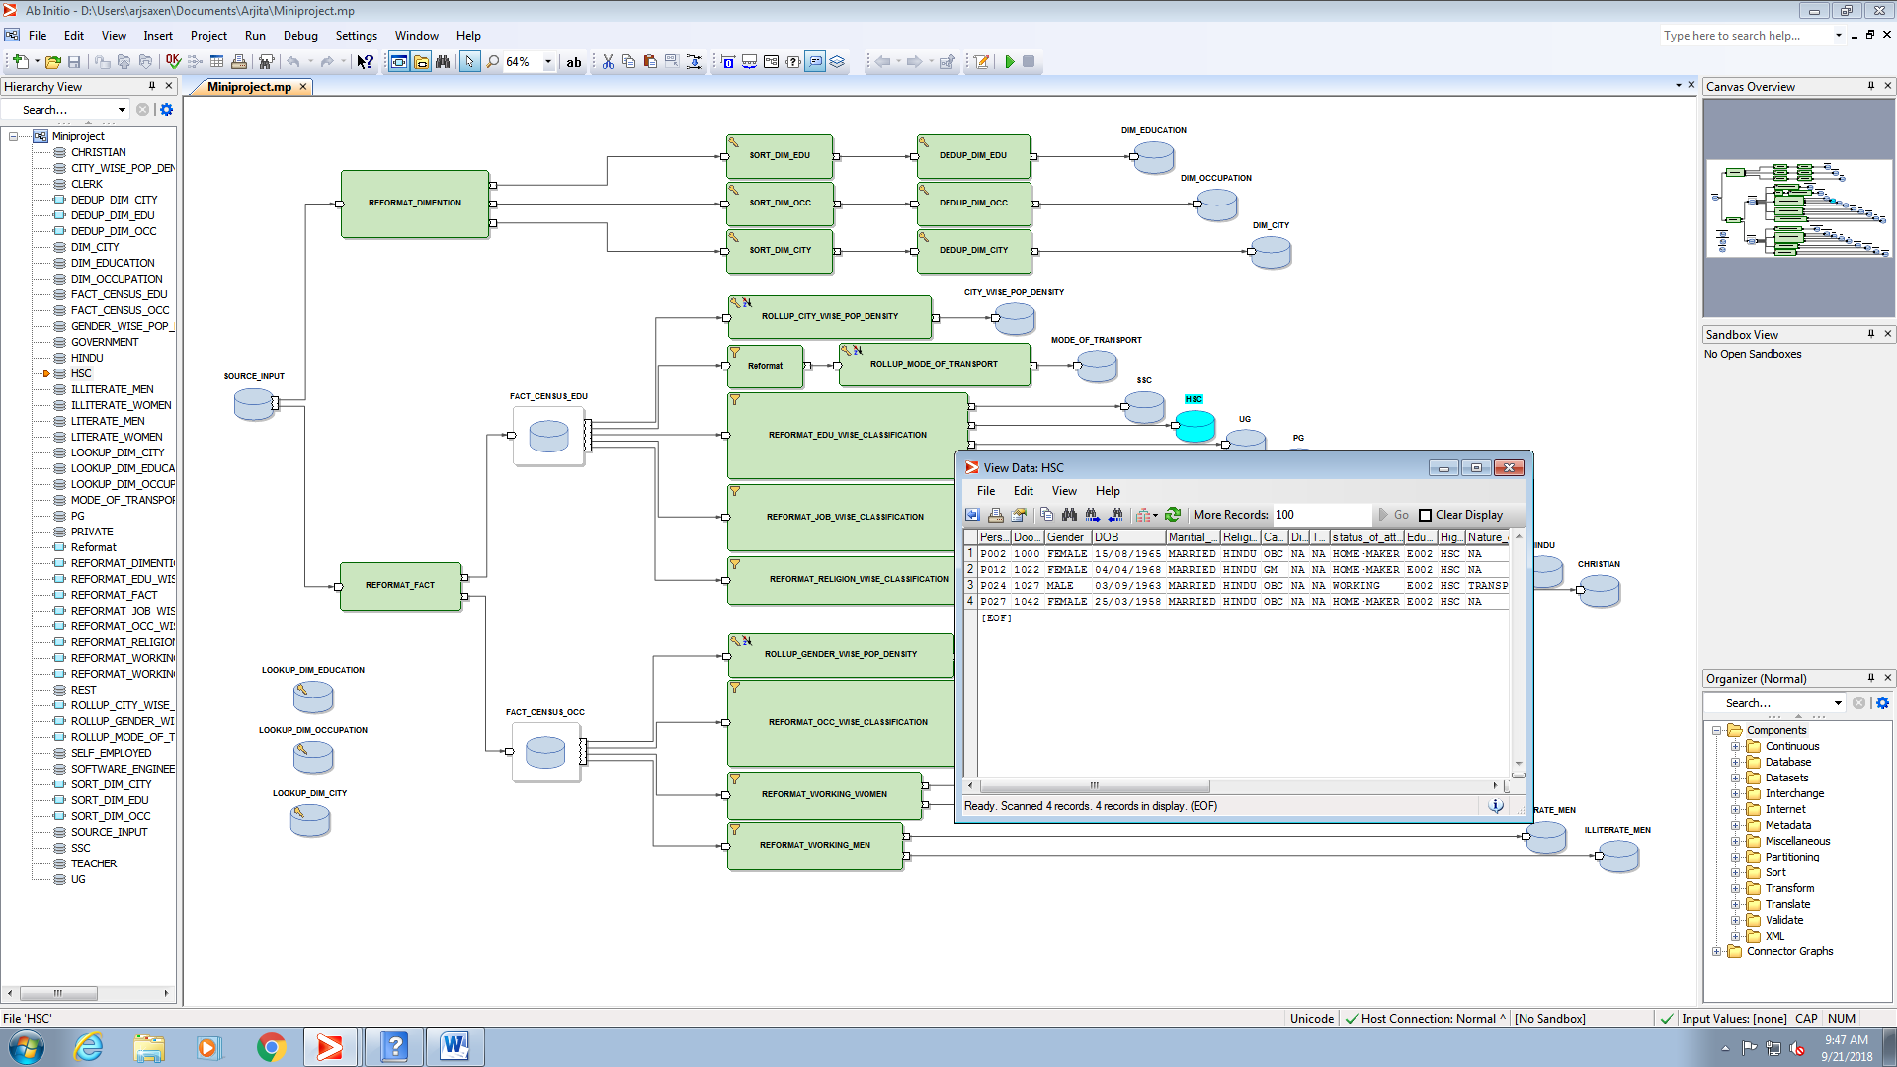
4. UG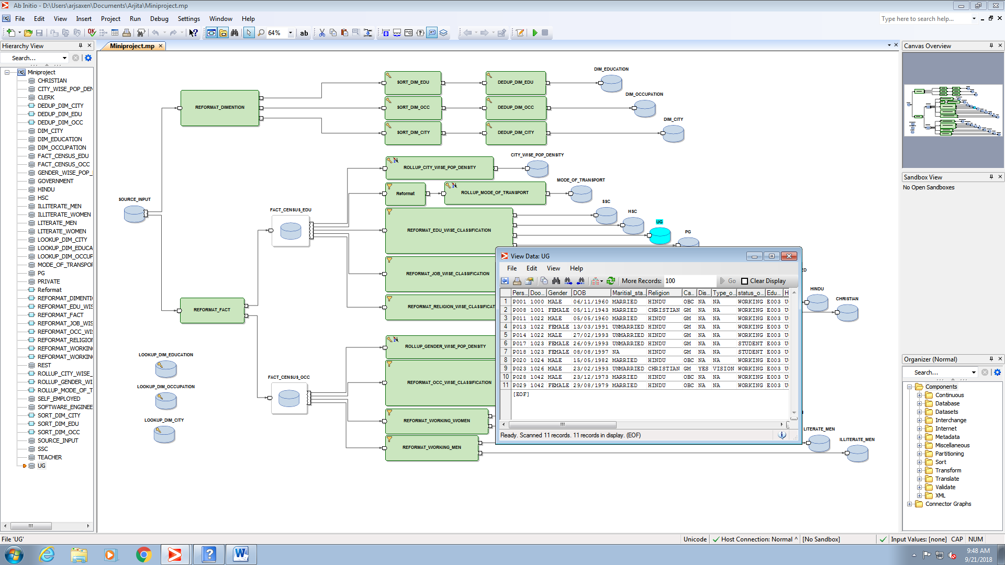
5. PG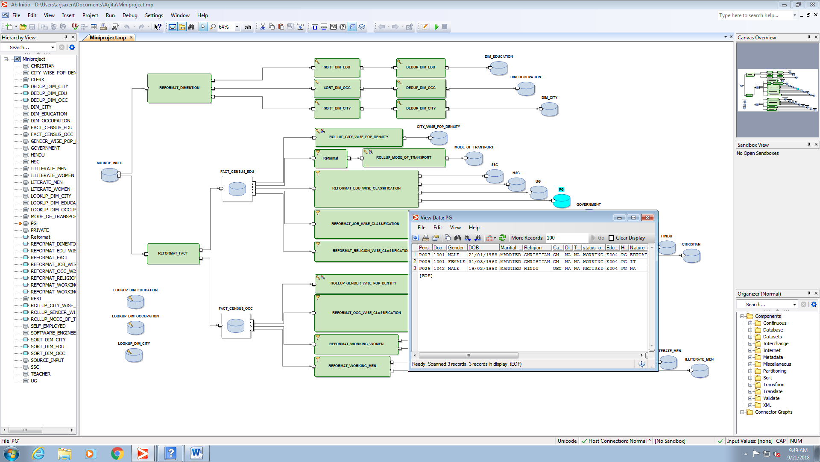
6. JOB WISE CLASSIFICATION

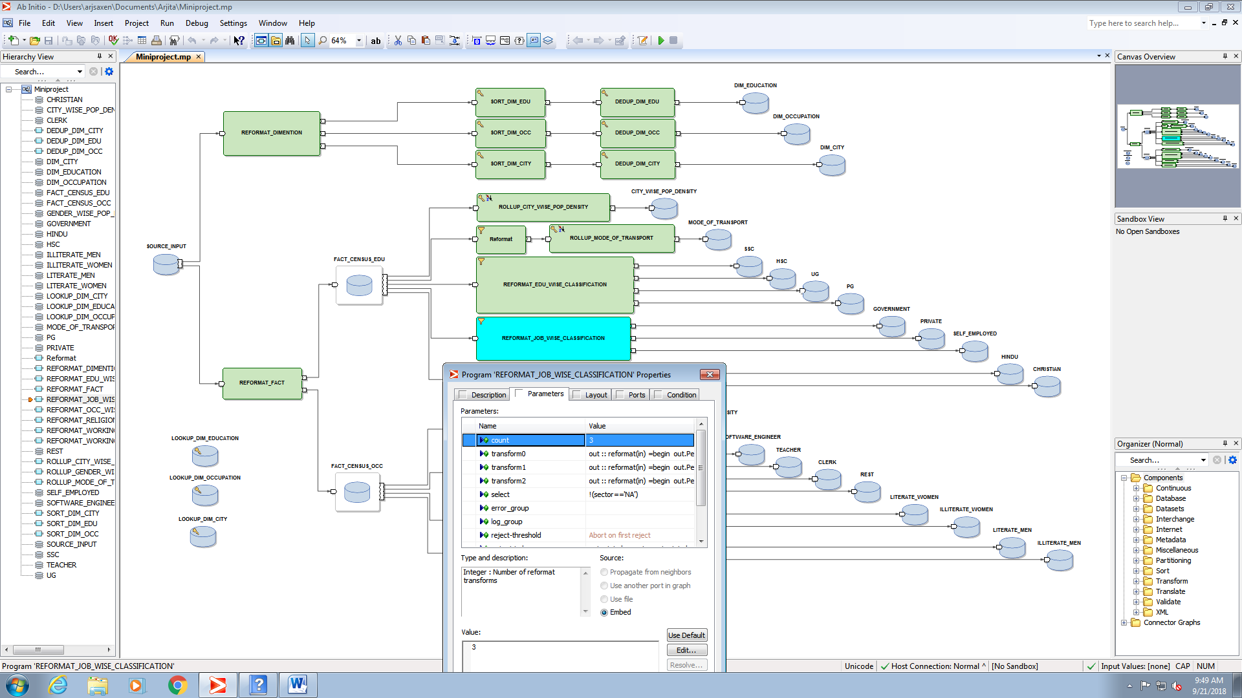

1. GOVERNMENT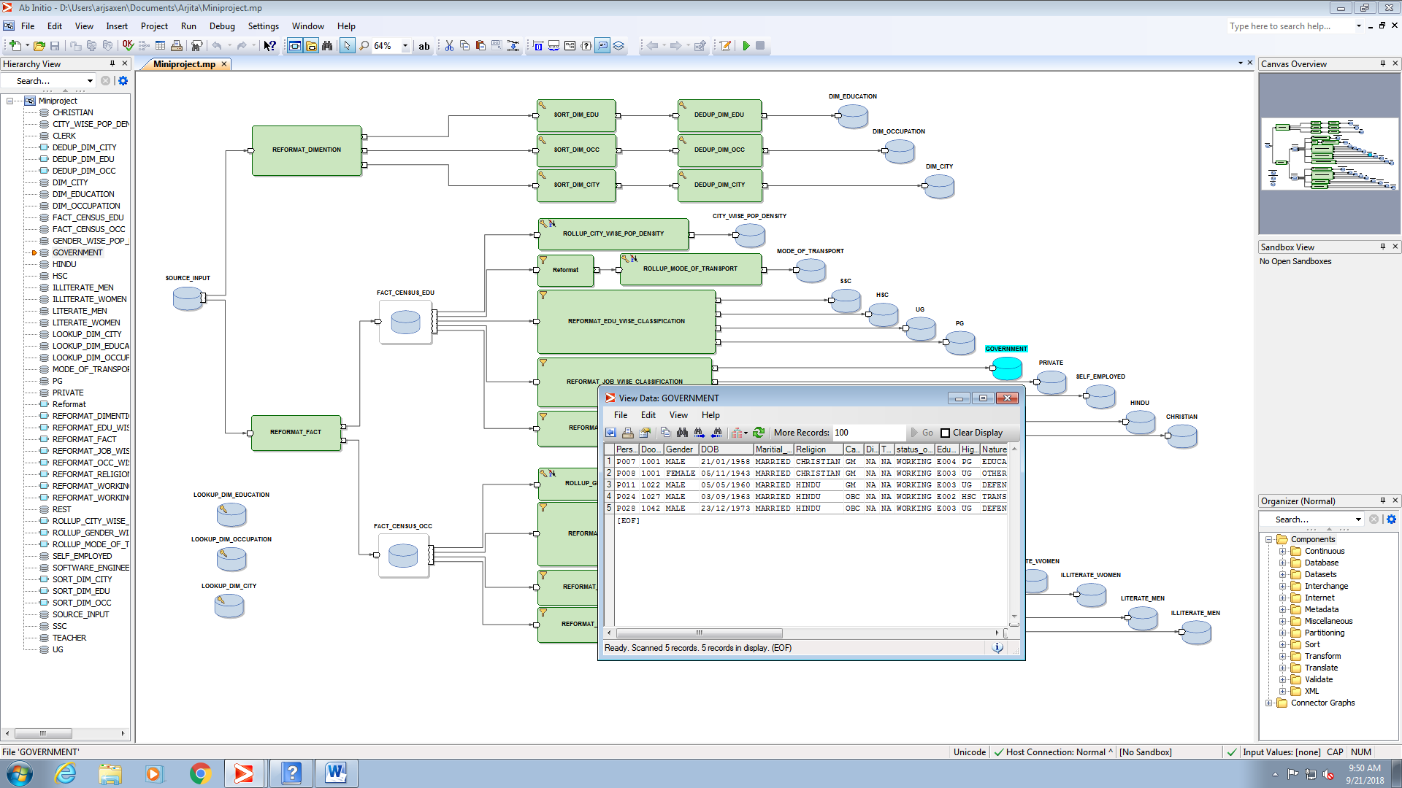
2. PRIVATE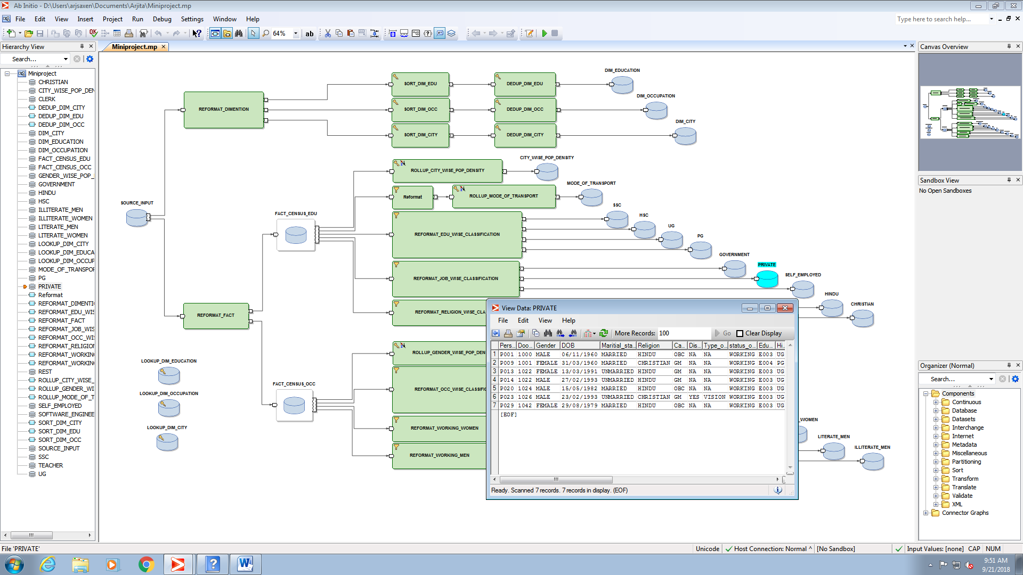
3. SELF EMPLOYEED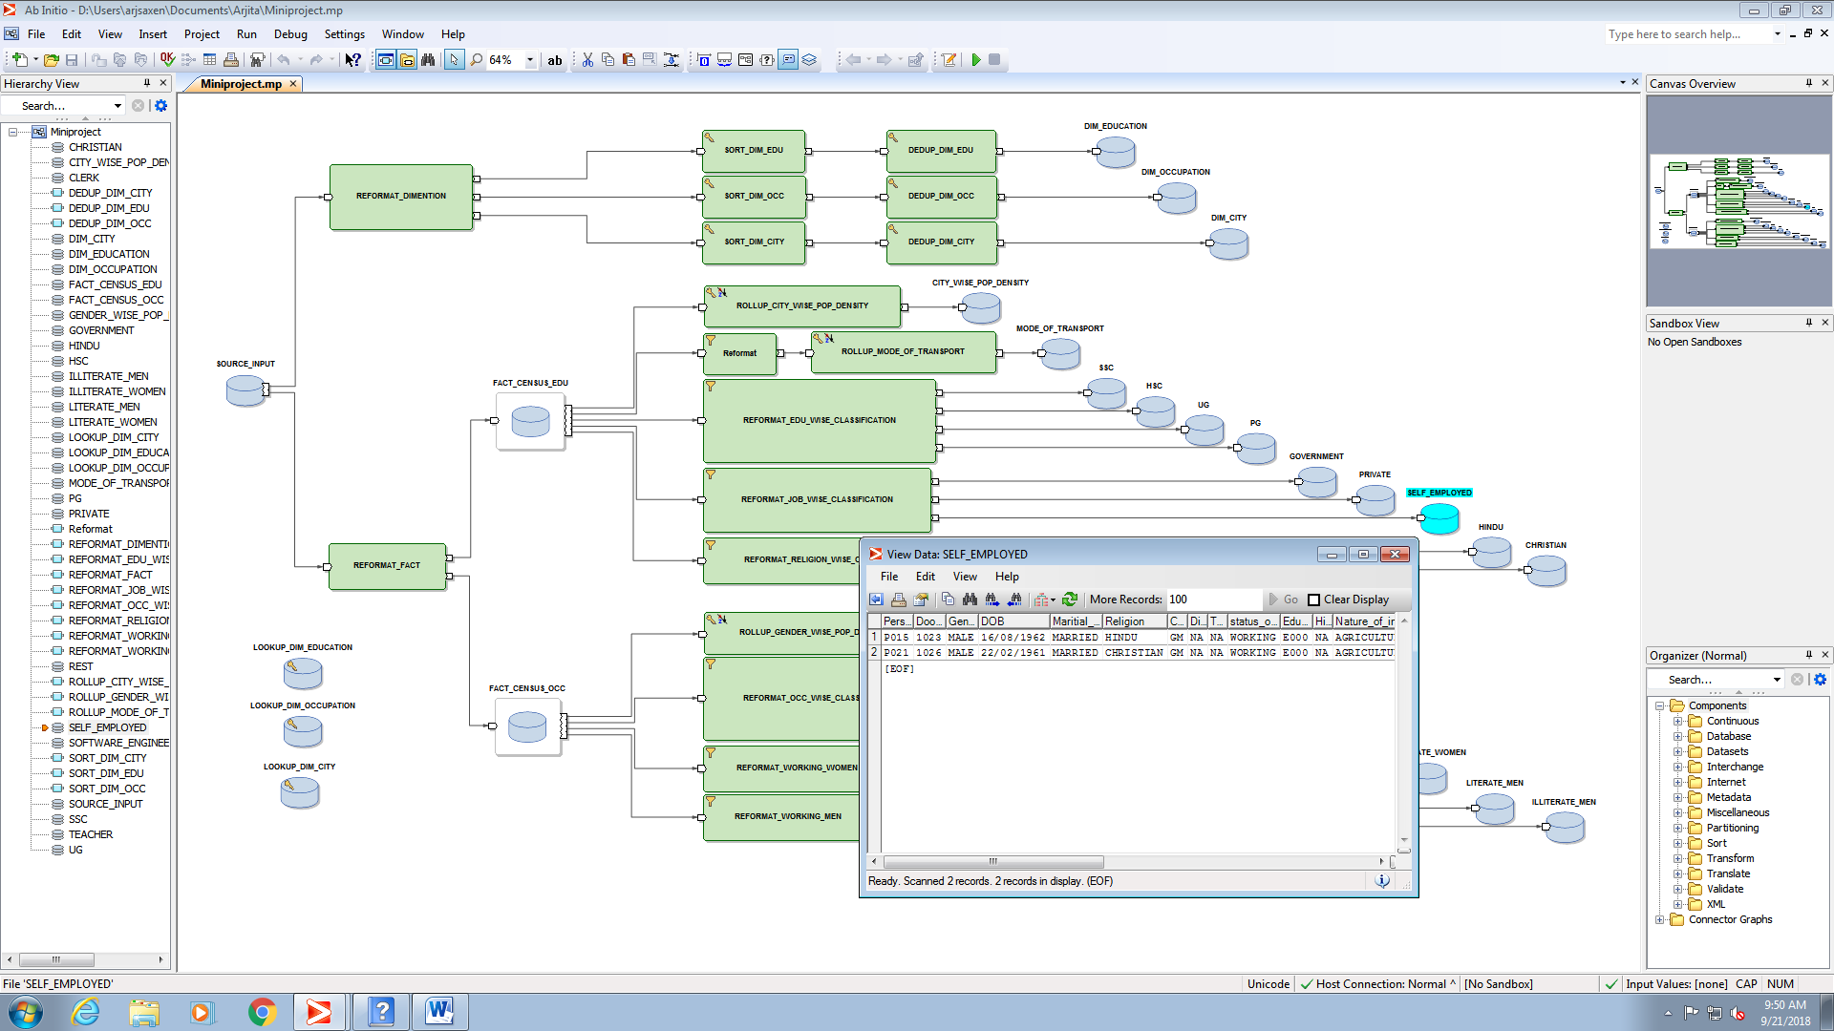
4. RELIGION WISE CLASSIFICATION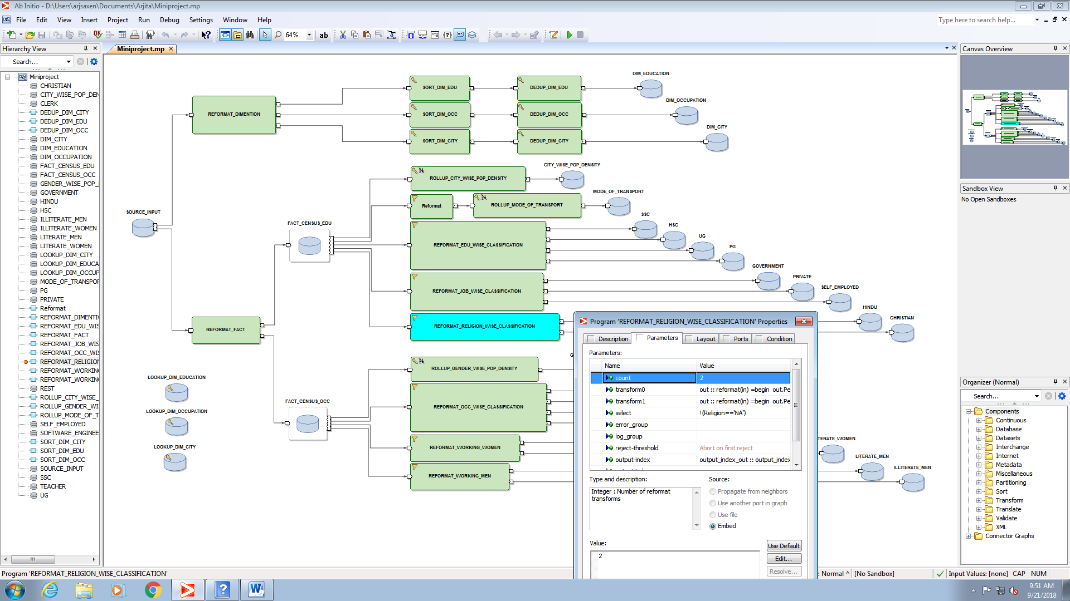
5. HINDU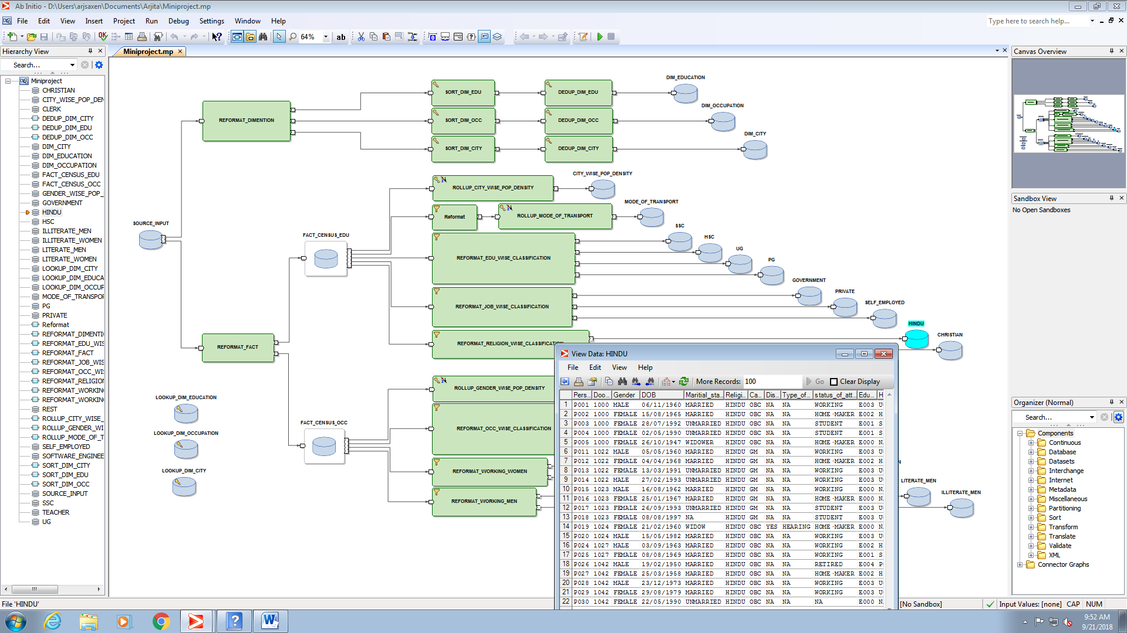
6. CHRISTIAN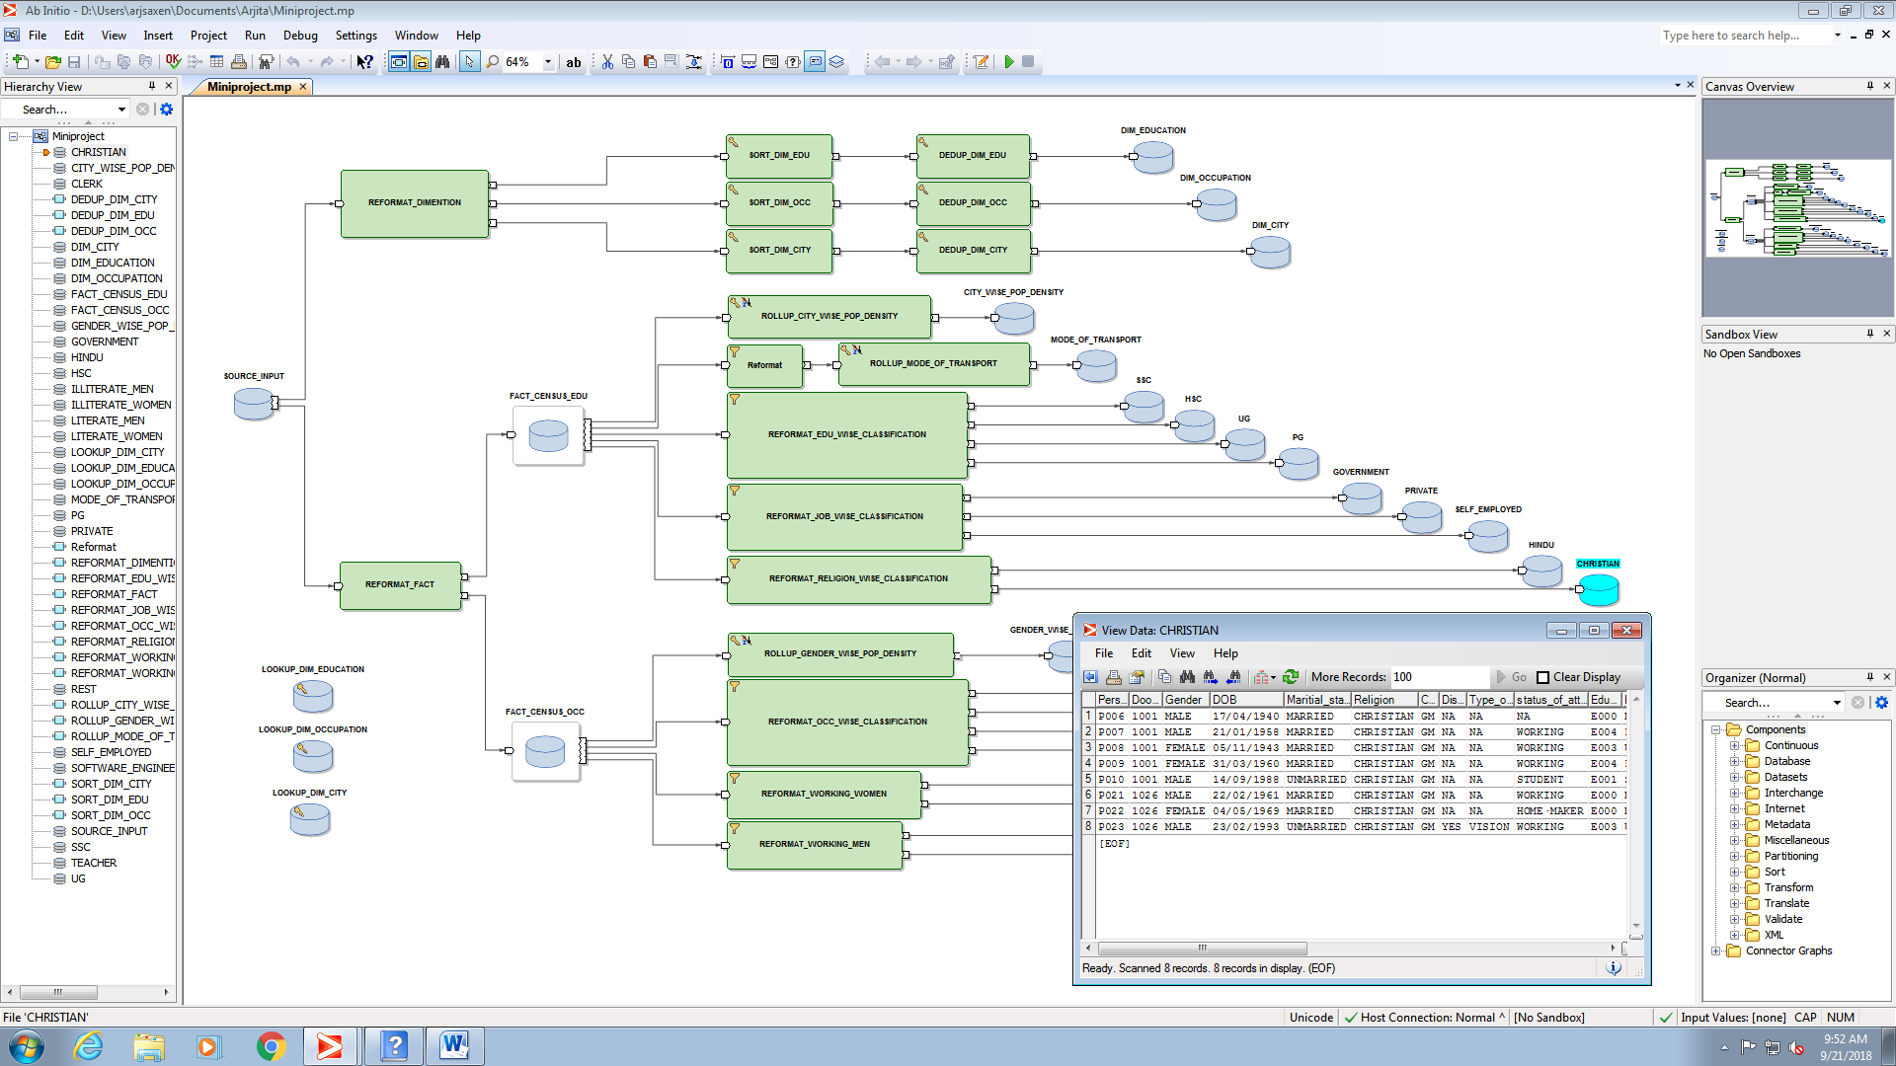
7. GENDER WISE POPULATION DENSITY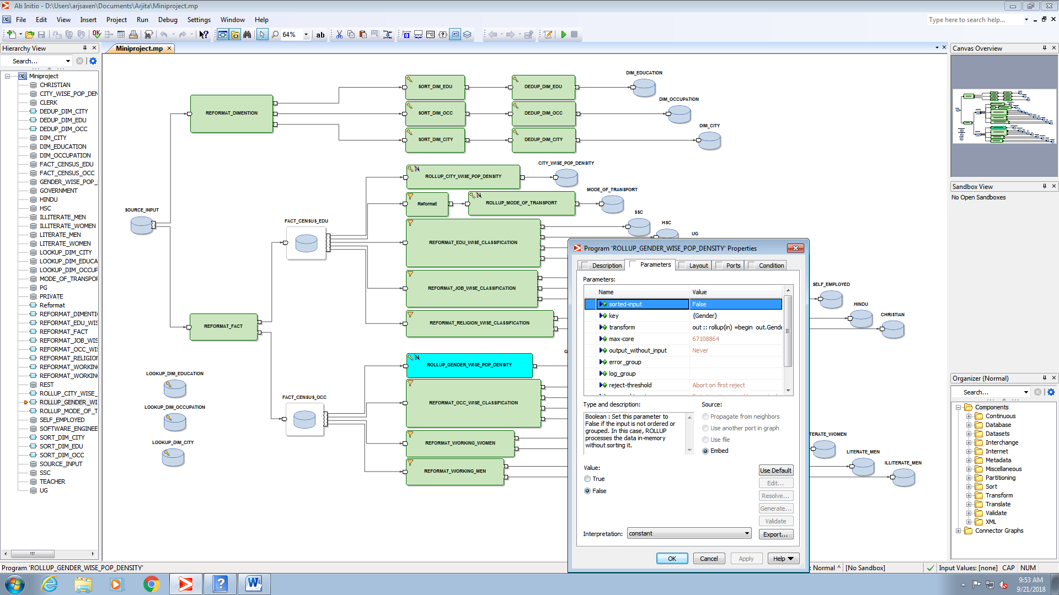

OUTPUT: 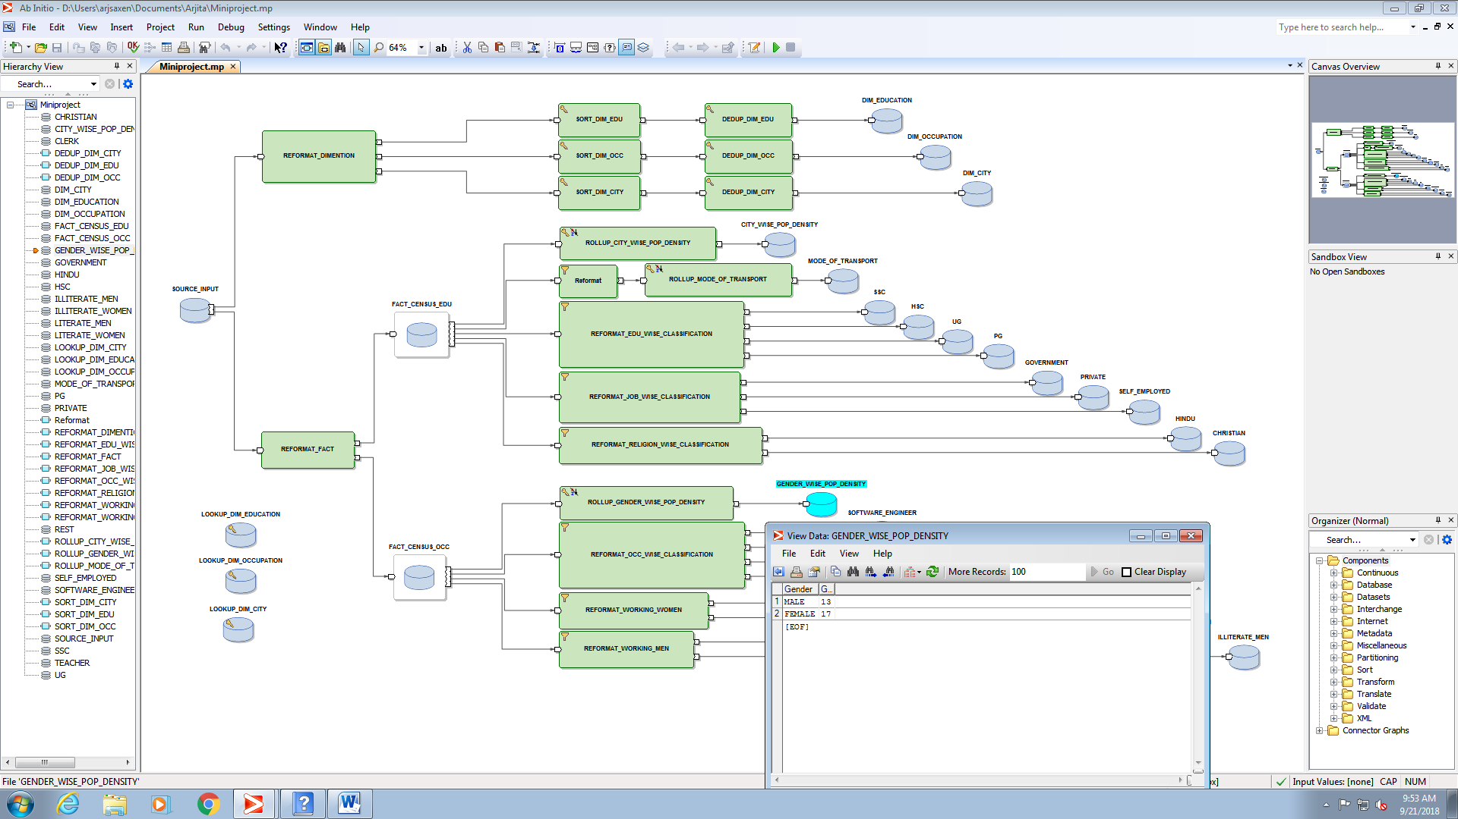

1. OCCUPATION WISE CLASSIFICATION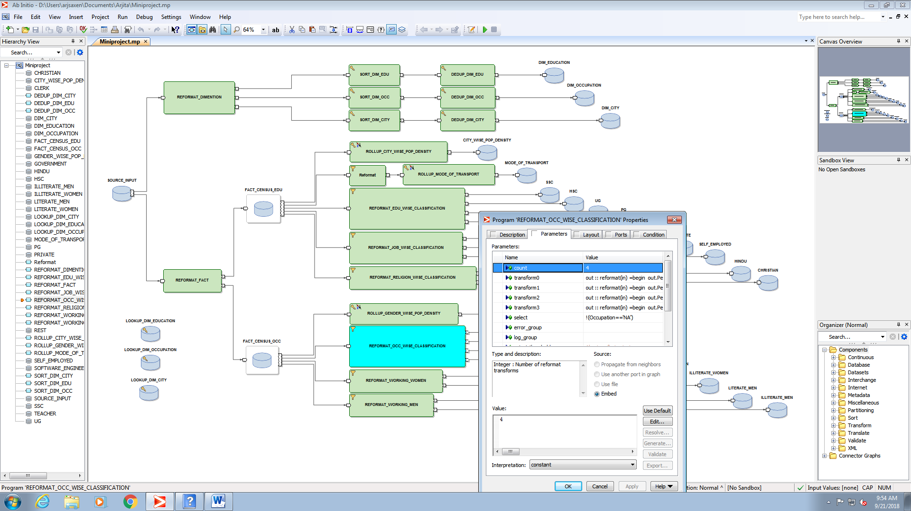
2. SOFTWARE ENGINEER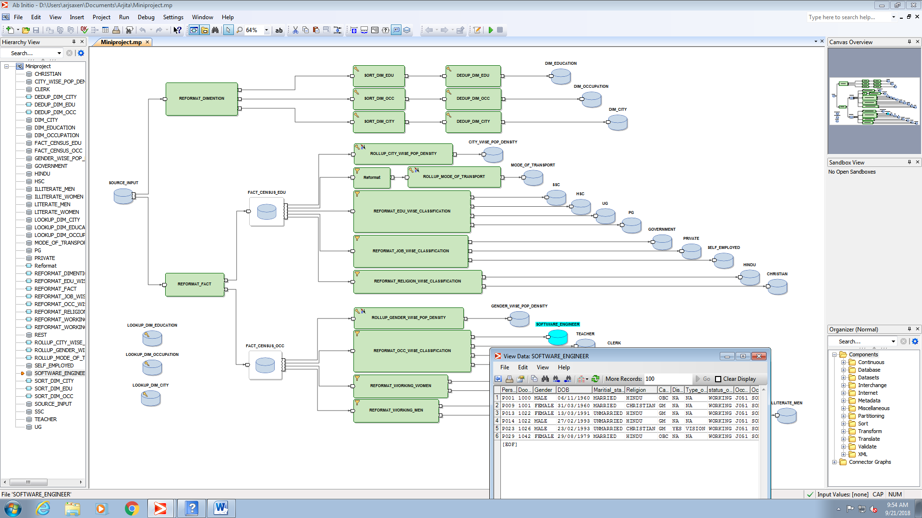
3. TEACHER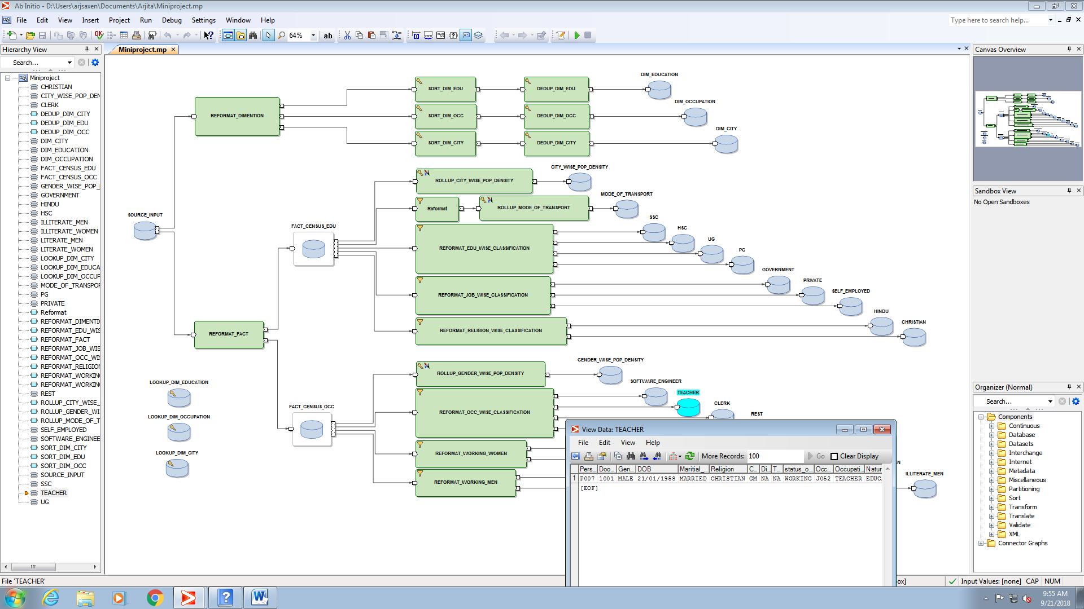
4. CLERK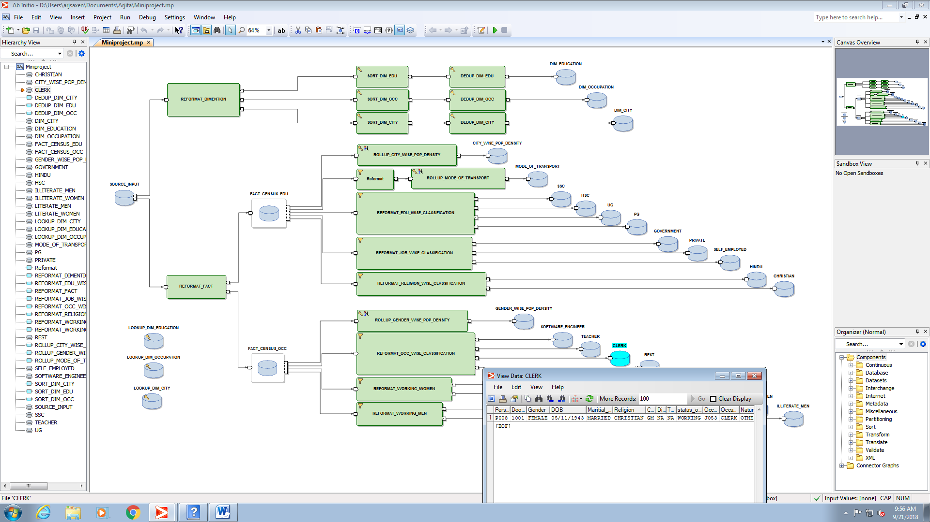
5. REMAINING OCCUPATIONS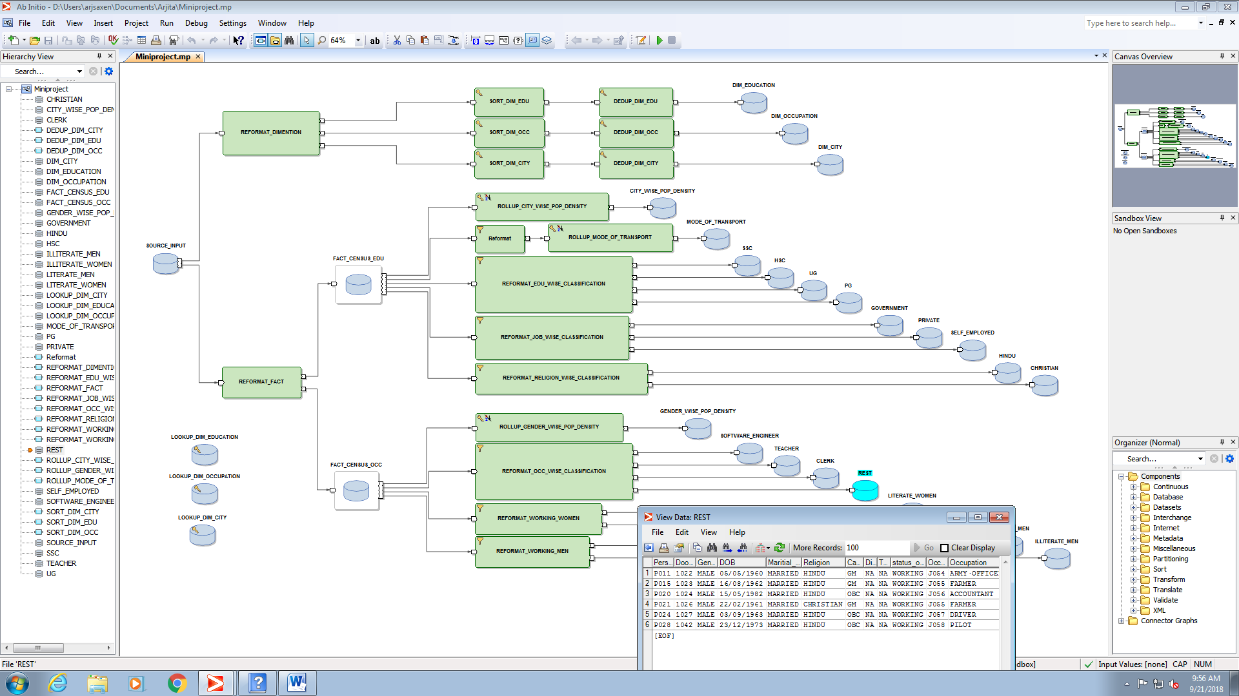
6. WORKING WOMEN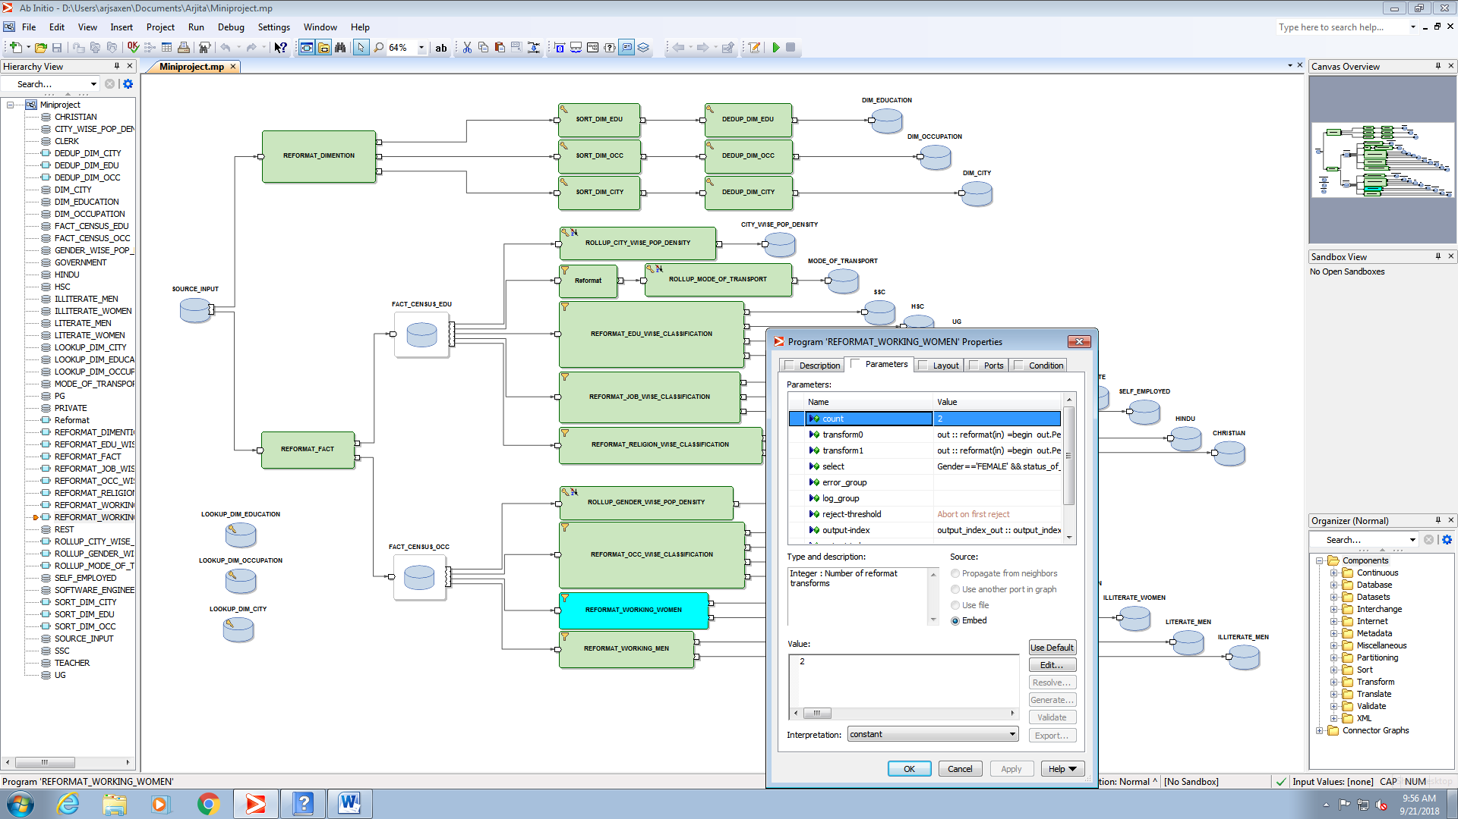
7. LITERATE WORKING WOMEN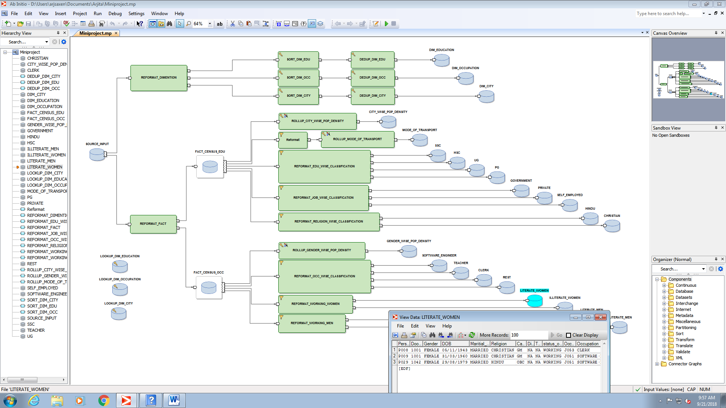
8. ILLITERATE WORKING WOMEN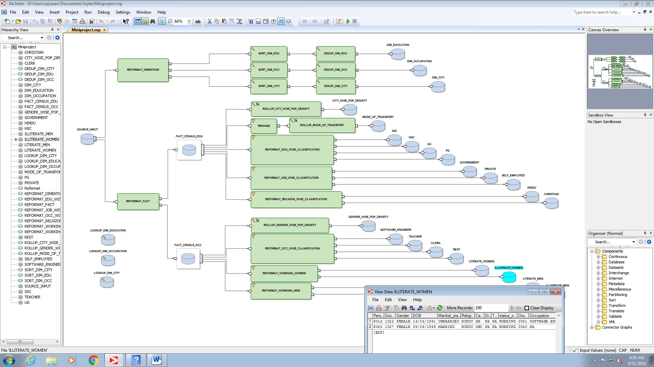
9. WORKING MEN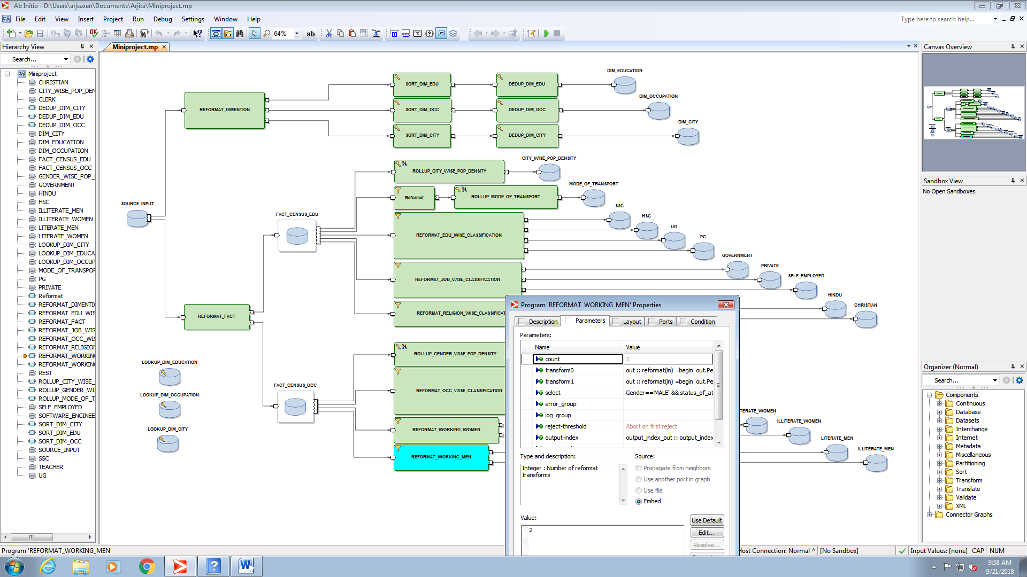
10. LITERATE WORKING MEN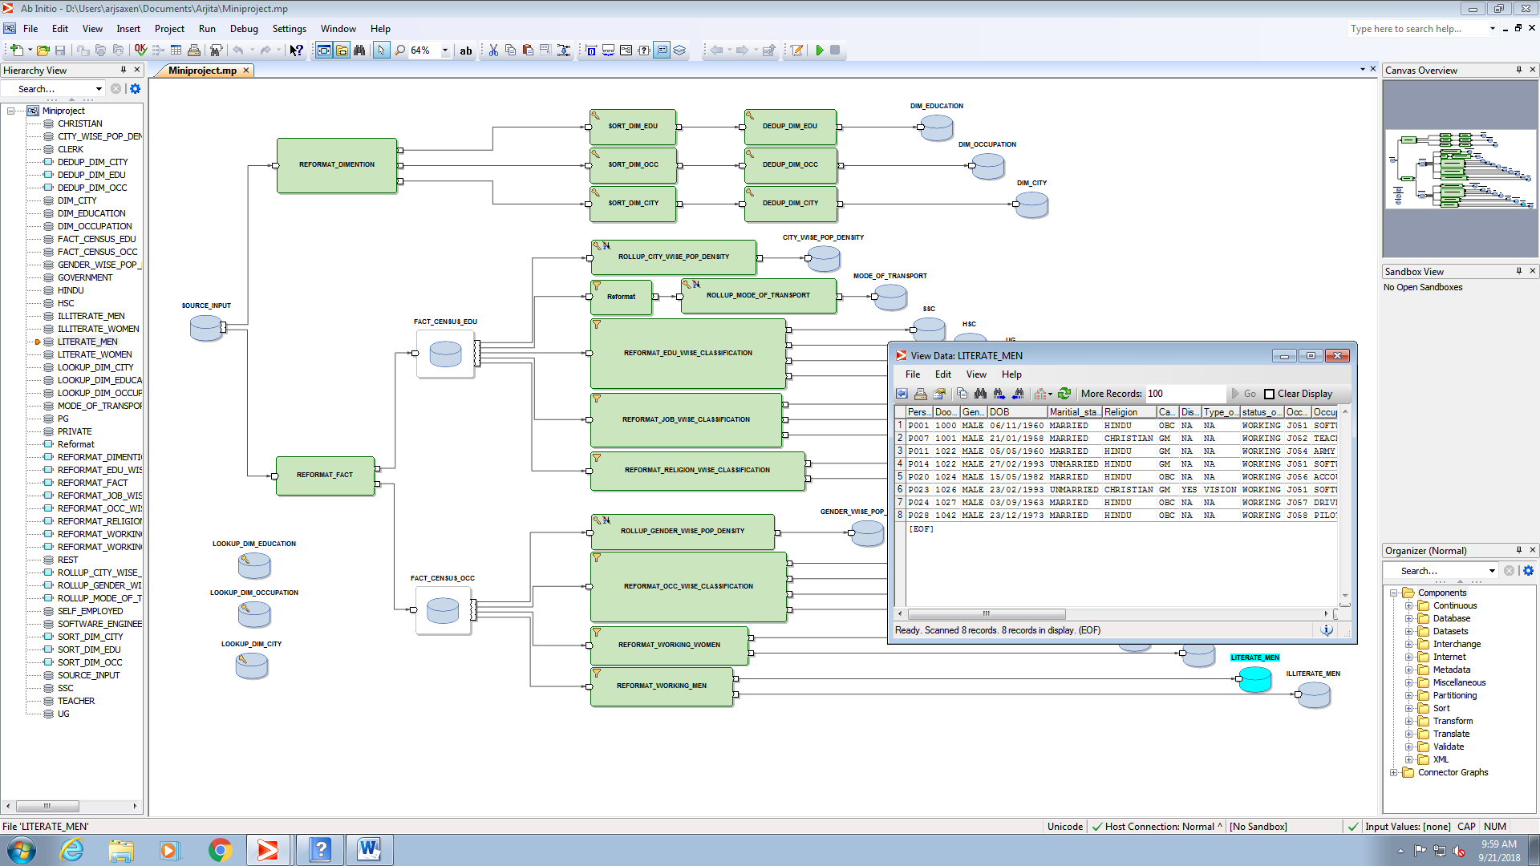
11. ILLITERATE WORKING MEN